A Forgotten Piece of Space Junk is Headed for Earth

The object could be a lost piece of a rocket dating back to the Apollo missions

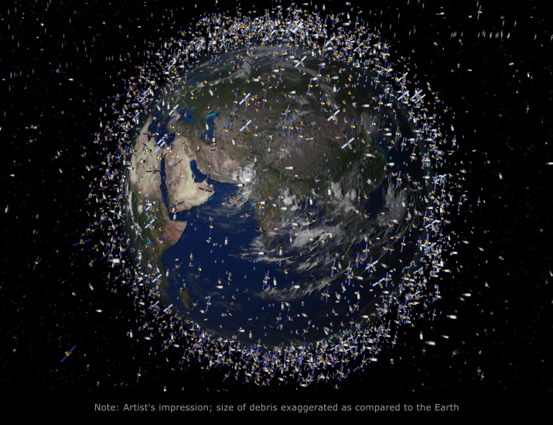

Hundreds of thousands of man-made fragments of debris orbit around the Earth, as depicted here in an illustration of the cosmic mess. (Science Photo Library/Corbis)

By [**Danny Lewis**](https://www.smithsonianmag.com/author/danny-lewis/)

SMITHSONIAN.COM   
OCTOBER 28, 2015

In just a few weeks, a forgotten piece of space junk will re-enter the Earth’s atmosphere above the Indian Ocean. Astronomers initially detected the object two years ago, but they’re still unsure what it actually is.

After more than 60 years of flinging rockets, space stations and satellites into orbit, the sky has gotten pretty crowded. While Earth’s orbit isn’t quite as cluttered [as in the future envisioned in “WALL-E,”](https://youtu.be/JiIZaDfPHqQ?t=12s) there is still plenty of debris left over from old satellites and space launches littering the sky.

Known as ‘[space junk,](http://www.nasa.gov/mission_pages/station/news/orbital_debris.html)’ this debris is often found in low orbit around Earth and is tracked by several space agencies, including the European Space Agency, NASA and the U.S. military.

What’s curious about this new piece of space junk is how recently it was discovered and how odd its orbit is. [According to the ESA](http://www.esa.int/Our_Activities/Operations/Space_Situational_Awareness/Reentry_data_will_help_improve_prediction_models), the mysterious object, called WT1190F, was first detected in 2013 by scientists at [the Catalina Sky Survey](http://www.lpl.arizona.edu/css/), a project that scans the sky for near-Earth objects like asteroids and comets.

Unlike most space junk, WT1190F has an elliptical orbit that takes it deep into space. At its furthest point from Earth, the object is about twice as far as the distance between the Earth and the Moon, [Traci Watson writes for *Nature News*](http://www.nature.com/news/incoming-space-junk-a-scientific-opportunity-1.18642).

Judging by its trajectory, scientists believe that it is just a few meters wide, not very dense and could be hollow. This data suggests that the space junk could be a part of an old rocket, panels from a past moon mission, or some other “lost piece of space history that’s come back to haunt us,” Harvard astrophysicist [Jonathan McDowell tells Watson](http://www.nature.com/news/incoming-space-junk-a-scientific-opportunity-1.18642).

The object will re-enter the Earth’s atmosphere above the Indian Ocean on November 13th. But there’s no need to worry: WT1190F is tiny, cosmically speaking. While most of it will probably burn up as it re-enters the atmosphere near the Sri Lankan coast, astronomers are excited for the rare chance to watch how WT1190F acts as it rockets through the sky.

Most funding and attention goes towards tracking space debris in low-Earth orbit, as it can interfere with communications satellites. Much less is known about objects in far-flung orbits like WT1190F, which is why it went for so long without being detected. Now that the object is on its way here, astronomers will get to test out a new set of tracking systems designed to detect and analyze debris with erratic orbits like this one, [Alissa Walker reports for *Gizmodo*](http://gizmodo.com/the-mysterious-object-on-a-collision-course-with-earth-1738979728).

In the meantime, get ready for some spectacular shots of WT1190F plummeting back to Earth. While it may not be on track to cause any damage, the piece of junk should burn brightly enough to be visible during the day.

Name______________________________________Date_________________ Hour____

Purple **Summary Frame**

**Directions: Use the below outline to complete a summary of your reading. Fill in the blanks as you go! Do not repeat a word over and over again.**

In the (article/essay/chapter/ report) _______________________________ entitled (title)_______________________________________________________________________

The (author/writer/reporter) _______________________________ (verb: explores, investigates, discusses) ______________________________(topic)__________________________________

First, (author/writer) _________________________ (verb) _________________________

(important detail in your own words) _______________________________________________

____________________________________________________________________________________________________________________________________________________________

In addition, (author/writer)_____________________ (verb) _____________________________

(important detail in your own words) _______________________________________________

____________________________________________________________________________________________________________________________________________________________

Moreover, (writer/author) ____________________(verb) _______________________________

(important detail in your own words) ______________________________________________

____________________________________________________________________________________________________________________________________________________________

Finally, (the author/writer) _____________________________ concludes that (overall summary of what your learned/main points of the article) ______________________________________

____________________________________________________________________________________________________________________________________________________________ I know this because in the (article/essay/chapter/ section) _______________________________

It states “_____________________________________________________________________

_____________________________________________________________________________”

(___________________, _________________________,______________)

Author Date published P.#

***Extra credit*** On a piece of computer paper draw a labeled, detailed, colored picture of the forgotten space junk heading or orbiting Earth.