PHYSICS **Baseball: From pitch to hits**

**The ballpark brings home plenty of science**

[**STEPHEN ORNES**](https://www.sciencenewsforstudents.org/author/stephen-ornes)

AUG 21, 2013 — 1:10 PM EST



 When the bat hits the ball, the ball goes flying. A lot happens in that split second, as energy is transferred from the player to the bat, and then to the ball.

ISTOCKPHOTO

On June 12, the Kansas City [**Royals**](http://kansascity.royals.mlb.com/index.jsp?c_id=kc) played at home against the Detroit [**Tigers**](http://detroit.tigers.mlb.com/index.jsp?c_id=det). When Royals centerfielder Lorenzo Cain stepped up to the plate at the bottom of the ninth, things looked grim. The Royals hadn’t scored a single run. The Tigers had two. If Cain struck out, the game would be over. No player wants to lose — especially at home.

Cain got off to a rocky start with two strikes. On the mound, Tigers pitcher Jose Valverde wound up. He let fly a special fastball: The pitch whizzed toward Cain at more than 90 miles (145 kilometers) per hour. Cain watched, swung and CRACK! The ball flew up, up, up and away. In the stands at Kauffman Stadium, 24,564 fans watched anxiously, their hopes rising with the ball as it climbed through the air.

The cheering fans weren’t the only ones watching. Radar or cameras track the path of virtually every baseball in major league stadiums. Computer programs can use those tools to generate data about the ball’s position and speed. Scientists also keep a close eye on the ball and study it with all those data.

Some do it because they love baseball. Other researchers may be more fascinated by the science behind the game. They study how all of its fast-moving parts fit together. Physics is the science of studying energy and objects in motion. And with plenty of fast-swinging bats and flying balls, baseball is a constant display of physics in action.

Scientists feed game-related data into specialized computer programs — like the one called PITCH f/x, which analyzes pitches — to determine the speed, spin and path taken by the ball during each pitch. They can compare Valverde’s special pitch to those thrown by other pitchers — or even by Valverde himself, in previous games. The experts also can analyze Cain’s swing to see what he did to make the ball sail so high and far.

“When the ball leaves the bat with a certain speed and at a certain angle, what determines how far it will travel?” asks Alan Nathan. “We’re trying to make sense of the data,” explains this physicist at the University of Illinois at Urbana-Champaign.

When Cain swung his bat that night, he connected with Valverde’s pitch. He successfully transferred energy from his body to his bat. And from the bat to the ball. Fans may have understood those connections. More importantly, they saw that Cain had given the Royals a chance to win the game.

**Precision pitches**

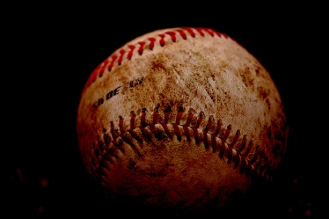

The 108 stitches on a baseball can slow it down and cause it to move in unexpected directions. Credit: Sean Winters/flickr

Physicists study the science of a moving baseball using natural laws that have been known for hundreds of years. These laws aren’t regulations enforced by the science police. Instead, natural laws are descriptions of the way nature behaves, both invariably and predictably. In the 17th century, physics pioneer Isaac Newton first put into writing a famous law that describes an object in motion.

Newton’s First Law states that a moving object will keep moving in the same direction unless some outside force acts upon it. It also says that an object at rest won’t move without the prodding of some outside force. That means a baseball will stay put, unless a force — like a pitch — propels it. And once a baseball is moving, it will keep moving at the same speed until a force — such as friction, gravity or the swat of a bat — affects it.

Newton’s First Law gets complicated quickly when you’re talking about baseball. The force of gravity constantly pulls down on the ball. (Gravity also causes the arc traced by a ball on its way out of a ballpark.) And as soon as the pitcher releases the ball, it starts to slow due to a force called drag. This is friction caused by air pushing against the baseball in motion. Drag shows up any time an object — whether a baseball or a ship — moves through a fluid, such as air or water.

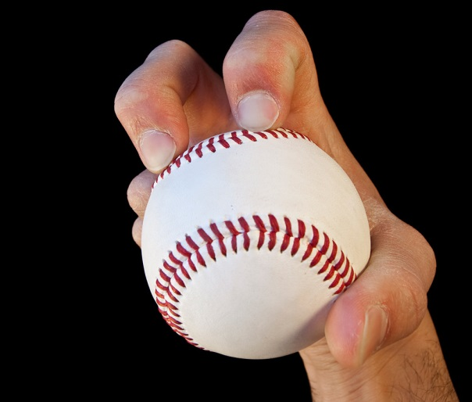

This photo shows how a knuckleball pitcher holds the ball. A knuckleball is a pitch that spins little, if at all. As a result, it seems to wander to home plate — and it’s hard both to hit and to catch. Credit: iStockphoto

“A ball that arrives at home plate at 85 miles per hour may have left the pitcher’s hand 10 miles per hour higher,” says Nathan.

Drag slows a pitched ball. That drag depends on the shape of the ball itself. The 108 red stitches roughen a baseball’s surface. This roughness may change how much a ball will be slowed by drag.

Most pitched balls also spin. That also affects how forces act on the moving ball. In a 2008 paper published in the *American Journal of Physics,*for example, Nathan found that doubling the backspin on a ball caused it to stay in the air longer, fly higher and sail farther. A baseball with backspin moves forward in one direction while spinning backwards, in the opposite direction.

Nathan is currently researching the knuckleball. In this special pitch, a ball barely spins, if at all. Its effect is to make a ball seem to wander. It may fly this way and that, as if it were indecisive. The ball will trace an unpredictable trajectory. A batter who can’t figure out where the ball is going won’t know where to swing either.

“They’re hard to hit and hard to catch,” Nathan observes.

In the Royals game against the Tigers, Detroit pitcher Valverde threw a splitter, the nickname for a split-finger fastball, against Cain. The pitcher throws this by placing the index and middle fingers on different sides of the ball. This special kind of fastball sends the ball zipping quickly toward the batter, but then causes the ball to appear to drop as it nears home plate. Valverde is known for using this pitch to close down a game. This time, the baseball didn’t drop enough to fool Cain.

“It didn’t split too good and the kid hit it out of the park,” observed Jim Leyland, the Tigers manager, during a press conference after the game. The ball soared over the players on its way out of the field. Cain had hit a home run. He scored, and so did another Royals player already on base.

With the score tied, 2-2, the game headed into extra innings.

**The smash**

Success or failure, for a batter, comes down to something that happens in a split-second: The collision between a bat and the ball.

“A batter is trying to get the head of the bat in the right place at the right time, and with as high a bat speed as possible,” explains Nathan. “What happens to the ball is mainly determined by how fast the bat is moving at the time of collision.”

At that moment, energy becomes the name of the game.

In physics, something has energy if it can do work. Both the moving ball and the swinging bat contribute energy to the collision. These two pieces are moving in different directions when they collide. As the bat smacks into it, the ball first has to come to a complete stop and then start moving again in the opposite direction, back toward the pitcher. Nathan has researched where all that energy goes. Some gets transferred from the bat to the ball, he says, to send it back where it came from. But even more energy goes into bringing the ball to a dead stop.

“The ball ends up kind of squishing,” he says. Some of the energy that squeezes the ball becomes heat. “If your body is sensitive enough to feel it, you could actually feel the ball heat up after you hit it.”

Physicists know that the energy before the collision is the same as the energy afterward. Energy cannot be created or destroyed. Some will go into the ball. Some will slow the bat. Some will be lost to the air, as heat.

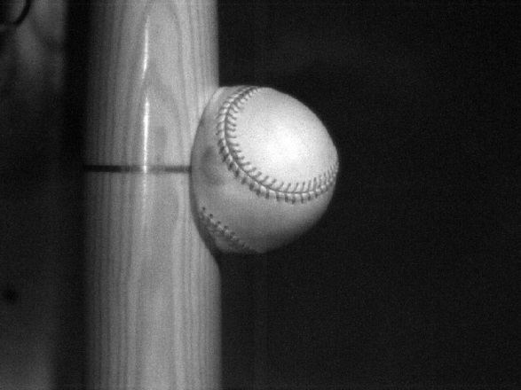

When a bat hits the ball, it can briefly deform the ball. Some of this energy that went into squeezing the ball will also be released to the air as heat. Credit: UMass Lowell Baseball Research Center

Scientists study another quantity in these collisions. Called momentum, it describes a moving object in terms of its speed, mass (the amount of stuff in it) and direction. A moving ball has momentum. So does a swinging bat. And according to another natural law, the sum of the momentum of both has to be the same before and after the collision. So a slow pitch and a slow swing combine to produce a ball that doesn’t go far.

For a batter, there’s another way to understand the conservation of momentum: The faster the pitch and the faster the swing, the farther the ball will fly. A faster pitch is harder to hit than a slower one, but a batter who can do it may score a home run.

**Baseball tech**

Baseball science is all about performance. And it starts before the players step onto the diamond. Many scientists study the physics of baseball to build, test and improve equipment. Washington State University, in Pullman, has a Sports Science Laboratory. Its researchers use a cannon to fire baseballs at bats in a box outfitted with devices that then measure the speed and direction of each ball. The devices also measure the motion of the bats.

The cannon “projects perfect knuckleballs against the bat,” says mechanical engineer Jeff Kensrud. He manages the laboratory. “We’re looking for perfect collisions, with the ball going straight in and going straight back.” Those perfect collisions allow researchers to compare how different bats react to the pitched balls.

Kensrud says they’re also looking for ways to make baseball a safer sport. The pitcher, in particular, occupies a dangerous place on the field. A batted ball can rocket right back toward the pitcher’s mound, traveling just as fast or faster than the pitch. Kensrud says his research team looks for ways to help the pitcher, by analyzing how long it takes for a pitcher to react to an incoming ball. The team is also studying new chest or face protectors that might lessen the blow of an incoming ball.

**Beyond physics**



Lorenzo Cain, No. 6 on the Kansas City Royals, saved his team from defeat when he blasted a home run on June 12 in a game against the Detroit Tigers. Credit: Kansas City Royals

The 10th inning of the Tigers-Royals game went unlike the previous nine. The Tigers didn’t score again, but the Royals did. They won the game 3-2.

As the happy Royals fans headed home, the stadium went dark. Though the game might have ended, information from it will continue to be analyzed by scientists — and not just physicists.

Some researchers study the hundreds of numbers, such as the tallies of hits, outs, runs or wins that every game generates.

These data, called statistics, can show patterns that otherwise would be hard to see. Baseball is full of statistics, such as data on which players are hitting better than they used to, and which aren’t. In a December 2012 paper published in the research journal *PLOS ONE*, researchers [**found**](https://www.sciencenewsforstudents.org/node/453) that players perform better when they’re on a team with a slugger who is on a hitting streak. Other researchers may compare statistics from different years to look for longer-term patterns, such as whether baseball players overall are getting better or worse at hitting.

Biologists, too, follow the sport with keen interest. In a June 2013 paper published in *Nature*, biologist Neil Roach from George Washington University in Washington, D.C., reported that chimps, like pitchers, can throw a ball at high speed. (Though don’t look for the animals on the mound.)

As for Cain, the Royals centerfielder, by halfway through the season he had hit only one more home run since that June 12 game against the Tigers. Still, statistics show Cain had by then improved his overall batting average to .259, after a slump earlier in the season.

That is just one way the scientific study of baseball continues to improve the game, for both its players and its fans. Batter up!

*This video of a knuckleball thrown by the Toronto Blue Jays’ R. A. Dickey shows how unpredictable these balls can be.*

**Power Words**

**biology**The scientific study of living things.

**drag** The slowing force exerted by air or other fluid surrounding a moving object.

**force**An influence that tends to change the motion of a body or produce motion or stress in a stationary body.

**energy**A property of matter or radiation that describes the ability to do work.

**friction**Resistance to motion that arises when one object moves over another.

**gravity**The force that attracts any body with mass, or bulk, toward any other body with mass. Earth’s gravity keeps things on the planet’s surface and pulls down flying baseballs.

**momentum**The quantity of motion of a moving body, measured as a product of its mass and velocity.

**Newton’s First Law**A description of how things move in nature, namely that a body continues in a state of rest or uniform motion in a straight line unless it is acted on by an external force.

**physics** The scientific study of the nature and properties of matter and energy.

**statistics**The practice or science of collecting and analyzing numerical data in large quantities.

**trajectory**The path traced by a flying object.

**work**The transfer of energy from one system to another, by the application of a force.

Directions:

1. With your table partner read your assigned section…

Yellow and purple: p. 1-2

Orange and blue: 3-4

Red and green: 5-6

2. When completing the following you may work with your table partner but you should be completing two separate assignments. On a separate piece of paper..

3. Write a summary of your sections (3-5 sentences)

4. What are the science concepts in your section?

5. Identify and explain two power words (different from everyone else at your table)

6. Draw a colored, detailed, labeled picture representing your section.