Name _____________________________________________ Date _____________ Hour _________

**Station 1: Light Exploration**

**Pre-activity**: 1. define the following vocabulary words, be sure to use the definitions in relation to light.

Incident-

Transmit-

Absorb-

Reflect-

Scattering-

Refraction-

2. On the diagram below label where the light is being transmitted, reflected, and absorbed.

-Add a fourth ray and label it refracting.

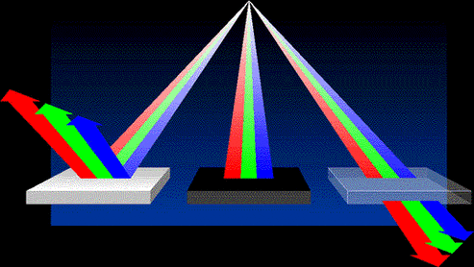

**Light Exploration Activity**

Task: You and your group are going to investigate how light behaves when it interacts with materials of different clarity (clearness). You will record written observations and diagrams to help you respond to the Focus Question: How does light beave through mediums of different clarity? After the investigation, you will construct a simple model comparing and explaining how light behaves through three mediums of different clarity.

**Materials:** -laser -3 different cups -3 types of paper

**Task steps**

1. Start with the three different types of paper.

2. One at a time, hold each type of paper up, shine the laser light at each type of paper.

3. Record your observations and sketch a labeled diagram of your Data Table for each type of paper. Make sure your observations are detailed and describe everything you observe happening.

4. Next, you are going to test the tree types of cups.

5. One at a time, place each type of cup on the table on its side, with the bottom facing the laser.

6. Shine the laser at each cup.

7. Record your observations and sketch a labeled diagram on your Data Table for each type of cup.

|  |  |  |
| --- | --- | --- |
| Material  Name and describe the material you are testing | Observation (2 sentences)  Is the light transmitted or absorbed? Describe in detail | Diagram  Include all parts of the system and labels |
|  |  |  |
|  |  |  |
|  |  |  |
|  |  |  |
|  |  |  |
|  |  |  |

**Reflection Questions:** Answer the following questions using complete sentences and a restate. Include two vocabulary words within your answers and underline them.

1. Which materials behaved the same when light (the laser) hit them? How did they behave the same?

2. What is a pattern you notice between how clear a medium (Material) is and how light behaves?

3. How do you predict light will behave when it hits a clean piece of glass? A metal wall? A plastic container? Explain your responses.