**Light Behavior Extra Credit**

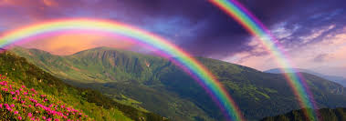

**Focus Question:** How are rainbows created?

**Task:**

1. Using your knowledge of light behavior, respond to the following phenomena question: **How are rainbows created?**

Construct an annotated model explaining how rainbows are created. Your model should be colored, and labeled. Include a description of how rainbows are created with textual evidence (5-7 sentences)

**Light Behavior Extra Credit**



**Focus Question:** How are rainbows created?

**Task:**

1. Using your knowledge of light behavior, respond to the following phenomena question: **How are rainbows created?**

Construct an annotated model explaining how rainbows are created. Your model should be colored, and labeled. Include a description of how rainbows are created with textual evidence (5-7 sentences)