**Laser Alarm System Study Guide**

**Vocab:** Define each word (Best to use your labs, articles and assignments from the class instead of a google search)

-Incident light -refraction of light -Absorption of light

-Scattering light -Transmission of light -Ultraviolet rays

-Reflection of light- -Gamma Ray -X-ray

-Infrared radiation -microwave rays -radio waves

-White light

**Answer the following questions.**

1. When a light passes through a _________________ it takes parallel light rays and bend them together.

2. A ______________ lens can take parallel light rays and bend them apart.

3. Light is **_____________**when it bounces off an object.

4. 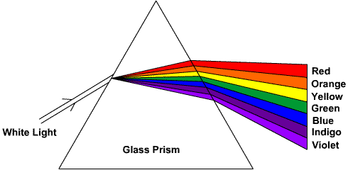 What is the light doing?

5. A prism is an example of what kind of light behavior?

6. A magnifying glass is an example of what kind of lens?

7. A telescope has what kind of lens?

8. Which lab demonstration showed refraction?

9. What happens to the light energy when it is absorbed?

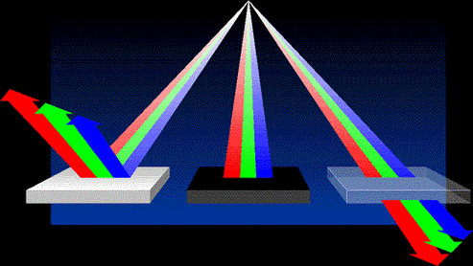

10. In the above picture identify where reflection, absorption and transmission is occurring.

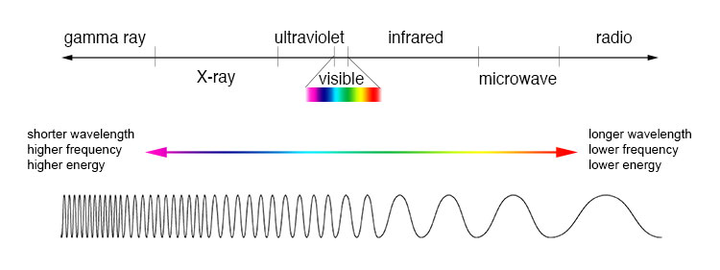

11. What is this a picture of?

A. What rays have the longest and shortest wavelengths?

B. Highest and shortest frequencies?

C. Highest and lowest energy?

**Written Responses**

12. Imagine you are shining a red light on a blue sheet of paper. Using the following vocabulary words explain what is happening what color light you see and identify the incident light, reflected light, transmitted and absorbed light.

13. How does light behave? When answering this question be sure to describe how and when light is absorbed, transmitted, reflected and refracted. Use examples, and evidence to support your answer.

Claim:

Lab evidence:

Research evidence:

Reasoning:

Include your sources

**There will be images of light passing through concave and convex lenses.