Name ___________________________________ Date __________________ Hour ____________
Day 1 Sound Waves through Different Mediums
Today we will be watching several videos, having class discussions and reading a short article on vacuums. Using the information you have gathered, construct a claim supported by evidence responding to the question: Is a vacuum a medium?
Focus Question: Is a vacuum a medium?
Pre-activity question:
1. What is a medium (in relation to sound)?

2. What is a sound vacuum?

Video #1: Sound traveling through different mediums. https://www.youtube.com/watch?v=Q3oItpVa9fs&feature=youtu.be
Video evidence: (Take note of the different mediums sound traveled through.

Read the article Vacuum Reading
Article evidence:

Video #2: How Long Could you Survive in Outer Space? https://www.youtube.com/watch?v=RjkrqMm52JI&feature=youtu.be
Video evidence:

Comprehension Questions: Answer using complete sentences and a restate.
1. Draw a picture of a medium (related to sound) with a caption.

2. Draw a picture of a vacuum (related to sound) with a caption.

3. Define a mechanical wave.

Example

4. Define an electromagnetic wave.

Example

5. What happens when you’re exposed to the vacuum of space?

6. Using a piece of evidence to support your claim (include the source) answer the focus question: Is a vacuum a medium?

Purple
Day 2: Read the article “Waves Traveling Through Different Mediums” with your table partner. Remember when we partner read, each person takes turns reading one paragraph and the opposite person summarize what was read. After each paragraph write a connection, summary or answer the provided question in the space provided.
Waves Traveling Through Mediums
Focus Question: How does sound travel differently through a solid, liquid, gas or vacuum?

“Waves Traveling Through Mediums” | Summaries connections
Sound waves are both mechanical waves and longitudinal waves and require a medium to travel through. When something makes a sound, the sound waves cause the molecules in matter to vibrate and bump into each other (see FIGURE 1).
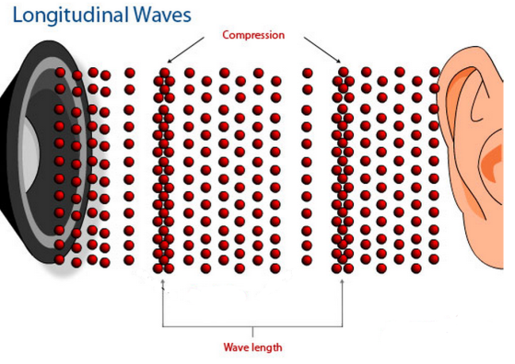
FIGURE 1
Sound waves, like all mechanical waves, need to travel through a medium such as a solid, liquid, or gas. The sound waves move through each of these mediums by vibrating from molecule to molecule through the matter (FIGURE 2). Because molecules are spaced differently between solids, liquids, and gases, sound travels through each state of matter at a different speed.

FIGURE 2
Sound Waves in a SOLID
The atoms or molecules in a solid are packed very tightly together, almost touching each other and remain in place. Since these particles are bonded tightly together, a sound wave moving from one solid molecule immediately transfers the sound wave to the next molecule touching it. Because there are no gaps between molecules, sound waves can travel very quickly from molecule to molecule in a solid without losing energy.
Sound Waves in a LIQUID
In a liquid, the atoms or molecules are touching each other, but they are not fastened to each other as strongly as they are in a solid. When sound waves travel through a liquid, some of sound's energy is wasted pushing the particles around because they can slide past each other. Sound cannot travel across gaps between molecules, which can slow a sound wave down. Sound travels about four times faster and farther in water (liquid) than it does in air (gas).

Sound Waves in a GAS
In a gas (example: air), the molecules are far apart. For sound to travel through a gas, the molecules must move quite a distance before they collide with other molecules. Sound energy cannot move as quickly when the molecules are not in contact with each other. Sound waves travel about thirteen times faster in wood than air.

Sound Waves in a VACUUM
Sound travels by vibrating the particles in the medium so that they bump into each other. In a vacuum, there are very, very few particles to vibrate, so sound cannot travel.
Electromagnetic Waves in a VACUUM
How can we communicate with astronauts orbiting earth if sound waves cannot travel through space? We use radio waves. Radio waves travel through a vacuum because they are electromagnetic waves, and do not need a medium to travel. We can see light traveling through the space because light waves are also electromagnetic.
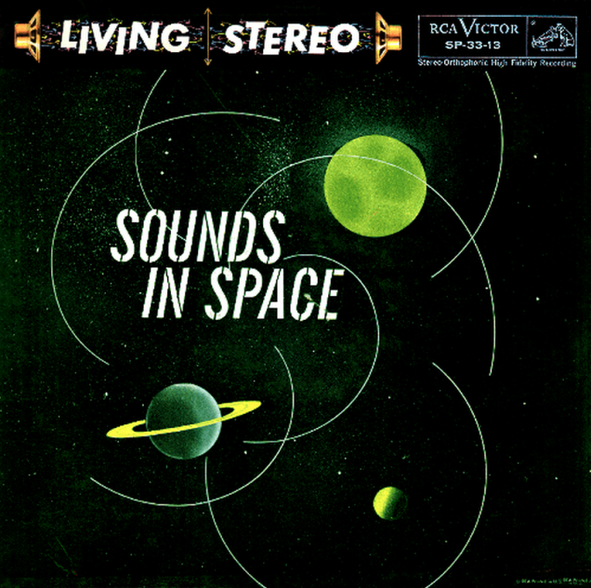 | Is the album cover scientifically accurate? Explain.

Answer the following questions using complete sentences and a restate.

1) How does sound travel differently through a solid, liquid, gas, or vacuum?

2) Dolphins and whales communicate through great distances underwater. How is this possible?

3) Native Americans who lived on the Great Plains used to put an ear on the ground to tell if buffalo or horses were coming. Why didn’t they listen through the air?

4) Would you expect sound waves to move faster on a hot day or a cold day? Explain your reasoning.

