**WHAT IS A VACUUM?**

A vacuum is an area in with little or no matter of any kind. In a vacuum, there are incredibly small amounts of molecules, atoms, or particles. A complete and absolute vacuum does not exist in nature. However, the emptiness of deep space and the universe come very close to a perfect vacuum with only tiny amounts of hydrogen atoms. 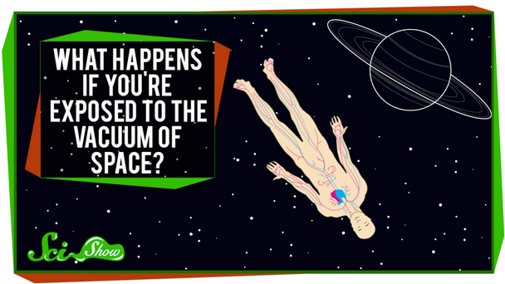

We can create vacuums in the laboratory by completely removing gas molecules from an airtight container using a vacuum pump (see image to the left). All **electromagnetic waves**, such as those shown in the image below, do not need a medium or matter to travel and can travel through a vacuum.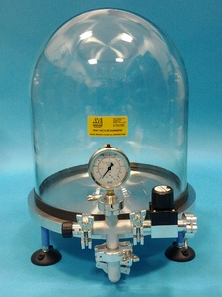

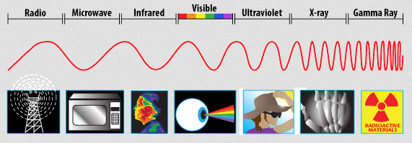

In a vacuum, there is not enough matter or particles to vibrate and help transport **mechanical waves**. Sound waves, like all mechanical waves, cannot travel through a vacuum or outer space because of the absence of a medium, or matter.