Name_____________________________ Date _________________ Hour __________

**Purple Fundamentals of Waves**

**Directions:** Read the article closely and talk to the text. Then, **answer the questions written in bold, underlined, using complete sentences with a restate.**

|  |  |
| --- | --- |
| **Talking to the Text: Focus on Vocabulary, Key Ideas, and add Captions** | **Annotations: Write Connections, Questions, Graphic Notes and/or Summarize** |
| **Essential Question: What is a Wave?**  Waves are rhythmic motions which transmit energy through matter or space. Mechanical waves such as sound or ocean waves must travel through a medium (matter) in the form of a solid, liquid or gas. Only electromagnetic waves, such as radio, light, and x-ray waves, can pass through outer space or a vacuum (contains no matter). See **FIGURE 1** to compare the wavelengths of different waves. |  |

**FIGURE 1**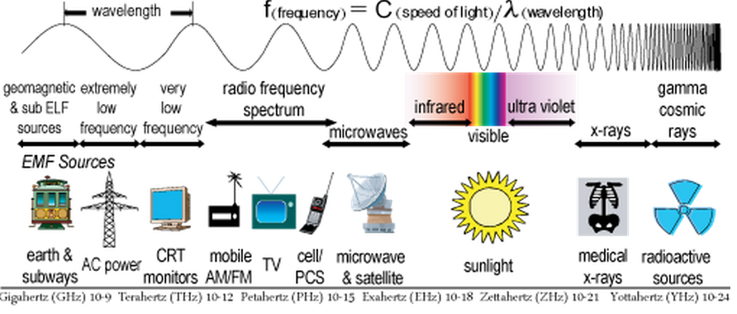

|  |  |
| --- | --- |
| **What Creates a Wave?**https://lh5.googleusercontent.com/dFt7u0z14ZA2tmsB12Ii1gfyNoL_EPZGTXg49gSZcP4_6SOJSTvi4Ef4V9Xu1NRe8SVbLtrJXlITzWRVEQRY0fDPHgJMASc3huM5R7OsQgoMy6w4GugairlVvsYdItmACzN_fFSf  All waves are created by a disturbance or event that transfers energy and creates vibrations. Vibrations produce waves. Vibrating vocal cords, for example, produce sound waves. When we speak, we disturb the air molecules and a wave is generated which reaches our ear. Vibrations of an electrical circuit produce radio waves. Ocean waves are vibrations created by the tides and wind. Seismic waves in the earth’s crust are created during earthquakes and can also trigger tsunamis underwater.https://lh5.googleusercontent.com/dFt7u0z14ZA2tmsB12Ii1gfyNoL_EPZGTXg49gSZcP4_6SOJSTvi4Ef4V9Xu1NRe8SVbLtrJXlITzWRVEQRY0fDPHgJMASc3huM5R7OsQgoMy6w4GugairlVvsYdItmACzN_fFSf |  |
| **Describing Waves**  **Mechanical waves** such as water waves and sound waves, are formed through the vibration of molecules in a medium (matter). **Electromagnetic waves** (such as light waves, UV [radiation](http://sciencelearn.org.nz/About-this-site/Glossary/radiation), microwaves and others) are formed through vibrating electric and magnetic fields and do not require molecules to travel. All waves behave in similar ways and can be described and measured by their wavelength, frequency, and amplitude (see **FIGURE 3**) |  |

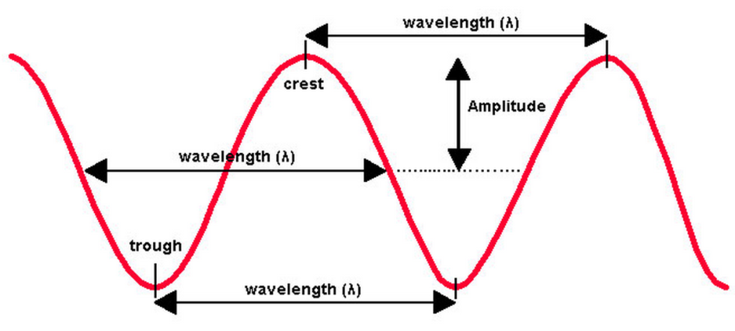

**FIGURE 3**

|  |  |
| --- | --- |
| **WAVELENGTHS** are defined as the length from one wave crest to the next (see **FIGURE 3**).  **Mechanical waves** have a wide variety of wavelengths as they travel through a medium. In water, ocean waves have wavelengths of 30–50 meters (90 - 150 feet), and tsunamis have much longer wavelengths, about 100 km (62 miles). Sound waves vary in wavelength according to the pitch of the sound – humans can hear sound with wavelengths between 70 millimeters to 70 meters (2.75 inches - 230 feet).  **Electromagnetic waves** vary greatly in wavelength, from the long wavelength of radio waves at about 10 m (33 feet), to the much shorter wavelengths of visible light at less than a millionth of a meter, to [X-rays](http://sciencelearn.org.nz/About-this-site/Glossary/X-ray) (less than a billionth of a meter). See **FIGURE 1**. |  |
| **FREQUENCY** is the number of wavelengths that travel past a point in 1 second of time. Frequency is measured in H[ertz](http://sciencelearn.org.nz/About-this-site/Glossary/hertz-Hz) (Hz - waves per second). A wave with a frequency of 20 Hz completes 20 wave cycles every second. For each type of wave, a longer wavelength means a lower frequency and a shorter wavelength  means a high frequency (see **FIGURE 4** below). |  |
| **AMPLITUDE** is half the total height of the wave, or the distance between the exact middle of a wave and its crest or trough (see **FIGURE 3**). Amplitude measures how much energy is being transported by the wave. The taller the wave, the greater the amplitude, and the more energy a wave has. |  |
| https://lh4.googleusercontent.com/-i4CFyfydjX15lNljrBSii3gRJFUohnChc2JvspxUWvAsdwBAe_oQO_yGq6FVSp1OBG1Qu9AEsqXjRnr0rjS-O1cat-drCcbAIXU1DS4tZg3NtaCBPgzqAOIqWmE-WeeVYV6UqoI  **FIGURE 4** |  |

**1)Explain with an annotated diagram: What kind of a wave is a tsunami and how are they formed?**

**2)Explain with an annotated diagram different ways we measure and describe waves.**