Name____________________________________ Date _________________ Hour _________

**Glass Bottle Music**

You will be guided through three activities. Your goal is to collect data to use as evidence to respond to the 3 sound questions.

**Investigation Questions:**

1. How are sounds produced by tapping the bottle with a pencil differ from those produced by blowing across the top?

Hypothesis:

2. How can you make a higher pitched sound? How can you make a lower pitched sound?

Hypothesis:

3. How can you make a sound louder and quieter?

Hypothesis:

**Step 1:** Video Exploration- Watch “Billie Jean” on Bottles and Glass Music Xylophone. While the videos are playing collect evidence that will help you answer our three investigation questions

|  |
| --- |
| 1. How are sounds produced by tapping the bottle with a pencil differ from those produced by blowing across the top? |
| 2. How can you make a higher pitched sound? How can you make a lower pitched sound? |
| 3. How can you make a sound louder and quieter? |

**Step 2:**

You will be given glass bottles, a glass of water and a pencil. With your group develop an experiment with the provided materials that will help you answer your questions and collect evidence to support you claim. Below write your procedure to answer each investigation question.

1.

2.

3.

**Checkpoint 1: Ms. Murphy Signature _____________________________________**

**Step 3:** Record your data. Use the infographics below and annotate with visuals, notes and details that clearly explain your discoveries from the investigation. Make a key below and be sure to complete all the steps in the checklist for each question.

___ organize your bottles from low pitch to high pitch (pitch = notes)

___ Mark and label the water levels in your diagram

___ Annotate your infographic to explain how sounds produced by striking the bottle differ from those produced by blowing across the top

___ Add visuals and annotations to your infographic to explain what produces the sound.

**Question 1:**

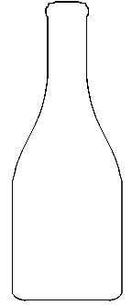

**Data Table:**

**Question 2:**



**Data Table:**

**Question 3:**



**Data Table:**

**Step 4:** After completing your lab organize your data into evidence that will help support your claim. Record your lab evidence below.

|  |
| --- |
| 1. How are sounds produced by tapping the bottle with a pencil differ from those produced by blowing across the top? |
| 2. How can you make a higher pitched sound? How can you make a lower pitched sound? |
| 3. How can you make a sound louder and quieter? |

**HOW DOES IT WORK?**

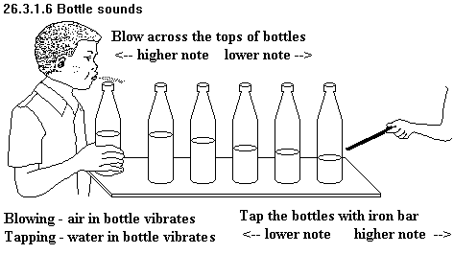

**What did I learn about sound?** Sound comes from vibrations. When you hit the bottle with the spoon, it makes the glass vibrate. When you fill the bottle with water, the glass cannot vibrate as much. Fast vibrations make a high sound and slow vibrations make a low sound. A full bottle will produce a slow vibration and a low sound. An empty bottle will have a faster vibration and a higher sound.

**My Big Discovery** - I thought that blowing into the bottle would be the same as hitting it with a spoon, but I was wrong. Blowing into the empty bottle made a low sound. I learned that when you blow into the bottle, you are making the *air* vibrate - not the glass! When you put more water into the bottle, there is less air to vibrate. This means the air will vibrate faster and the sound is higher.

**How it Works** - As you blow air across the lip of the bottle, the air inside the bottle flows out as new air flows back into the bottle. As the air leaves the bottle, the molecules vibrate and that vibration creates a sound. Pitch is a measure of the speed of the vibration. Rapid vibrations create a high pitch while slower vibrations result in a lower tone. You probably noticed that the pitch of the sound from the bottle changes as you add or subtract water. An empty bottle produces a lower pitch because there's lots of air in the bottle to vibrate. Adding water to the bottle decreases the amount of air space which means there is less air to vibrate. These vibrations happen more quickly and produce a higher pitch.

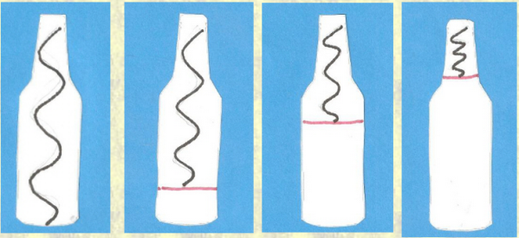

**Step 5:** After reading the above information, write down textual evidence that will help support your claim.

|  |
| --- |
| 1. How are sounds produced by tapping the bottle with a pencil differ from those produced by blowing across the top? |
| 2. How can you make a higher pitched sound? How can you make a lower pitched sound? |
| 3. How can you make a sound louder and quieter? |

**Step 6:** Analyze your results. You now have collect visual, lab and textual evidence. You must use a piece of evidence to answer each question. For each investigation question, state a claim and support it with a piece of evidence from our lab, video or text you must explain how your evidence supports your claim. Be sure to identify the source for your information and your explanation should describe what pitch occurred and why that pitch occurred. (Use words like vibration, and molecules)

1. How are sounds produced by tapping the bottle with a pencil differ from those produced by blowing across the top?

2. How can you make a higher pitched sound? How can you make a lower pitched sound?

3. Describe a low pitched sound without using the words loud, quiet, high or low.

4. Describe a high pitched sound without using the words loud, quiet, high or low.

5. Were all your hypothesis correct? Explain how you already knew the correct answer or explain when during the lab you discovered the correct answer.