A Forgotten Piece of Space Junk is Headed for Earth

The object could be a lost piece of a rocket dating back to the Apollo missions

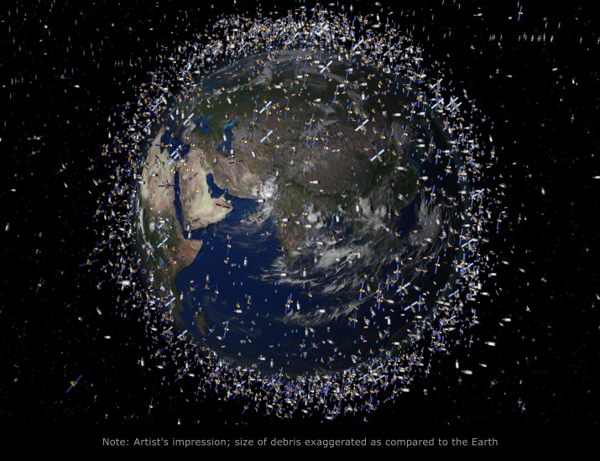

Hundreds of thousands of man-made fragments of debris orbit around the Earth, as depicted here in an illustration of the cosmic mess. (Science Photo Library/Corbis)

By [**Danny Lewis**](https://www.smithsonianmag.com/author/danny-lewis/)

SMITHSONIAN.COM   
OCTOBER 28, 2015

In just a few weeks, a forgotten piece of space junk will re-enter the Earth’s atmosphere above the Indian Ocean. Astronomers initially detected the object two years ago, but they’re still unsure what it actually is.

After more than 60 years of flinging rockets, space stations and satellites into orbit, the sky has gotten pretty crowded. While Earth’s orbit isn’t quite as cluttered [as in the future envisioned in “WALL-E,”](https://youtu.be/JiIZaDfPHqQ?t=12s) there is still plenty of debris left over from old satellites and space launches littering the sky.

Known as ‘[space junk,](http://www.nasa.gov/mission_pages/station/news/orbital_debris.html)’ this debris is often found in low orbit around Earth and is tracked by several space agencies, including the European Space Agency, NASA and the U.S. military.

What’s curious about this new piece of space junk is how recently it was discovered and how odd its orbit is. [According to the ESA](http://www.esa.int/Our_Activities/Operations/Space_Situational_Awareness/Reentry_data_will_help_improve_prediction_models), the mysterious object, called WT1190F, was first detected in 2013 by scientists at [the Catalina Sky Survey](http://www.lpl.arizona.edu/css/), a project that scans the sky for near-Earth objects like asteroids and comets.

Unlike most space junk, WT1190F has an elliptical orbit that takes it deep into space. At its furthest point from Earth, the object is about twice as far as the distance between the Earth and the Moon, [Traci Watson writes for *Nature News*](http://www.nature.com/news/incoming-space-junk-a-scientific-opportunity-1.18642).

Judging by its trajectory, scientists believe that it is just a few meters wide, not very dense and could be hollow. This data suggests that the space junk could be a part of an old rocket, panels from a past moon mission, or some other “lost piece of space history that’s come back to haunt us,” Harvard astrophysicist [Jonathan McDowell tells Watson](http://www.nature.com/news/incoming-space-junk-a-scientific-opportunity-1.18642).

The object will re-enter the Earth’s atmosphere above the Indian Ocean on November 13th. But there’s no need to worry: WT1190F is tiny, cosmically speaking.While most of it will probably burn up as it re-enters the atmosphere near the Sri Lankan coast, astronomers are excited for the rare chance to watch how WT1190F acts as it rockets through the sky.

Most funding and attention goes towards tracking space debris in low-Earth orbit, as it can interfere with communications satellites. Much less is known about objects in far-flung orbits like WT1190F, which is why it went for so long without being detected. Now that the object is on its way here, astronomers will get to test out a new set of tracking systems designed to detect and analyze debris with erratic orbits like this one, [Alissa Walker reports for *Gizmodo*](http://gizmodo.com/the-mysterious-object-on-a-collision-course-with-earth-1738979728).

In the meantime, get ready for some spectacular shots of WT1190F plummeting back to Earth. While it may not be on track to cause any damage, the piece of junk should burn brightly enough to be visible during the day.

Name ______________________ __________________ Date_______________ Hour________

**A Forgotten Piece of Space Junk**

**Directions :** Read the article “A Forgotten Piece of Space Junk, Headed to Earth”. While reading the artilce be sure to talk to the text. When you are finished below under the Give Two section write one interesting fact you learned from the article and one connection you made to the article and what we have already learned about space and gravity.

Give two

1.

2.

Get One: Below write one interesting fact or one connection another person made from the article

1.

**Bill Nye Gravity**

1. Every piece of matter in the universe has gravity and gravity always ______________________.

2. The pull is always towards the ____________________ of the planet.

3. No matter where you are on the surface of the Earth _________________________ is the same way.

4. The bowling ball and the apple hit the ground at the _____________________ time.

5. When the astronaut on the ___________________ dropped the feather and the hammer they hit the ground at the same time.

6. Gravity holds all the planets in ___________________.

7. When you step on a scale the Earth’s gravity ______________________.

8. The planets don’t get pulled all the way into the Sun because they are _____________________.

9. There is a balance between the force of gravity and the ____________________ of the planets.

10. If there were no gravity all the planets would go _________________________ into space.

11. When you are standing on the Earth you have ___________________ because you and the Earth

both have ________________________ and are attracted to each other.

12. Other planets in the solar system have a lot of _______________________ and so they also have gravity.

13. Jupiter is _________________ than the Earth so it has __________________ gravity.

14. The Moon is _________________ than the Earth so it has ________________ gravity.

15. Planets are ____________________ because of gravity.

16. Gravity makes something as small as an atom and as large as a planet _______________.