**Forces and Motion Study Guide**

**Vocab**

Mass Force Inertia

Friction Gravity Potential Energy

Kinetic energy velocity Momentum

Newton’s First Law of Motion Newton’s Second Law of Motion

Newton’s Third Law of Motion The Law of Conservation of Energy

Joules Mass Equation for Potential Energy

1. Know when it is appropriate to use a bar or line graph.

2.Compare the impulses, impact forces, and impact times of the following Race Car #1 (the race car that crashes to a stop by hitting the wall head on) and Race Car #2 (the race car that crashes to a stop by skidding a great distance along the wall)

3. Momentum is often used by sports commentators or political analysts to describe a team’s or candidate’s performance, yet in physics it has a specific meaning. What is the difference in the two meanings?

4. What determines if one car has more momentum than another in a two-car collision?

5. Explain why an 80,000 pound big rig traveling 2 mph has the same momentum as a 4,000 pound sport utility vehicle (SUV) traveling 40 mph.

6. Think of the tablecloth challenge, how to magicians use Newton’s First law to their advantage in pulling the tablecloth out from under an entire set of dishes?

7. Isaac Newton’s (circle one) **1st 2nd 3rd** Law of Motion states: A body at rest remains at ______________ unless acted upon by an external _________________, and a body in ______________ continues to move at a constant _______________ in a straight line unless it is acted upon by an external force.

8. Imagine that there are two eggs, one gets thrown against a brick wall and the second gets thrown into a bed sheet. Which egg experienced the greater impulse, the egg that hit the wall of the bed sheet? (Be careful here) Which egg experienced the greater force of impact? Which egg experiences the greater time of impact?

9. Explain how a small object (small mass) can have the same kinetic energy as a large object (large mass)

10. Describe the collision pictured below in terms of momentum, if the truck has four times the momentum of the car before the collision. (What is going to happen with the momentum?)

11. Describe the collision pictured below in terms of energy, if the truck has four times the energy of the car before the collision. (What is going to happen to the energy?) 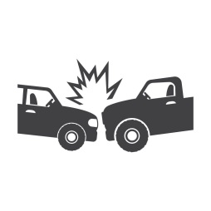

|  |  |
| --- | --- |
| Essential Question: How have we used force for innovation? | |
| Claim (Your answer): | |
| Lab Evidence: | Research Evidence: |
| Reasoning (Explain how your evidence supports your claim): | |