Craters
Focus Question: What are craters and how are they formed?

Talking to the Text:  Circle vocabulary words and unknown words, underline evidence that answers the focus question, Annotate pictures and titles | Annotations: Write Connections, Questions, Graphic Notes and/or Summarize
- What is a crater?  A crater is a bowl-shaped depression, or hollowed-out area, produced by the impact of a meteorite, volcanic activity, or an explosion. Craters are produced by the collision of a meteorite with the Earth (or another planet or moon) are called impact craters. The high-speed impact of a large meteorite compresses, or forces downward, a wide area of rock. The pressure pulverizes the rock. Almost immediately after the strike, however, the pulverized rock rebounds. Enormous amounts of shattered material jet upward, while a wide, circular crater forms where the rock once lay. Most of the material falls around the rim of the newly formed crater. | - What is a crater?  A crater is an impact site.
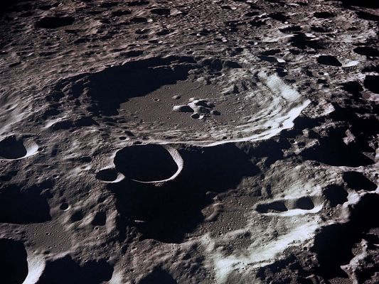
The surface of the moon is thought to have been formed by the Earth’s surface.

What do we know about lunar craters?

The Earth’s moon has many craters. Most were formed when meteors, bodies of solid matter from space, slammed into the lunar surface millions of years ago. Because the moon has almost no atmosphere, there is hardly any wind,erosion, or weathering. Craters and debris, called ejecta, from millions of years ago are still crystal-clear on the moon’s surface. Many of these craters are landmarks. Craters on the moon are named after everyone from American astronaut Buzz Aldrin to ancient Greek philosopher Zeno.
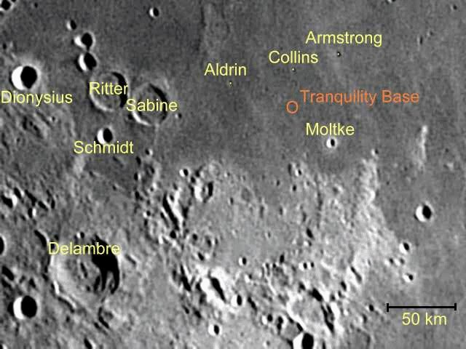
Surface of the Moon

What do we know about craters on Earth?
Many impact craters are found on the Earth’s surface, although they can be harder to detect. The forces of wind,rivers, and precipitation can scrape away evidence of a crater. Vegetation can also grow over the area.

One of the best-known craters on Earth is Meteor Crater, near Winslow, Arizona. The crater was created instantly when a 50-meter (164-foot), 150,000-ton meteorite slammed into the desert about 50,000 years ago. Meteor Crater is 1.2 kilometers (0.75 miles) in diameter and 175 meters (575 feet) deep.
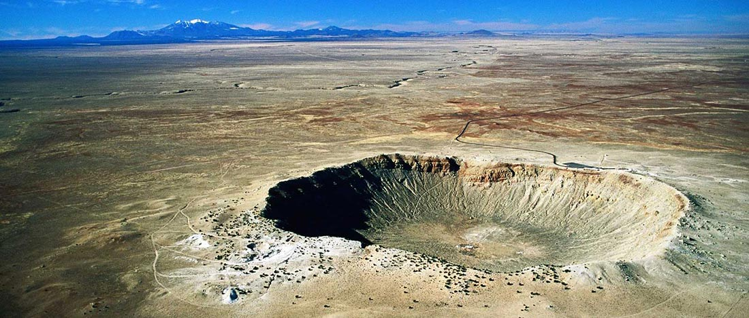
Meteor Crater in Winslow, Arizona

How have craters impacted planets?
The Chicxulub Crater, on Mexico’s Yucatan Peninsula, was most likely created by a comet or asteroid that hit Earth about 65 million years ago. The crater is 180 kilometers (112 miles) wide and 900 meters (3,000 feet) deep. The object that created the Chicxulub Crater was probably about 10 kilometers (6 miles) wide.

The impact was so powerful the crater is called the Chicxulub Extinction Event Crater. Scientists say half the species on Earth—including the dinosaurs—went extinct as a result of the impact. The event was more than a billion times more explosive than all the atomic bombs ever detonated on Earth.
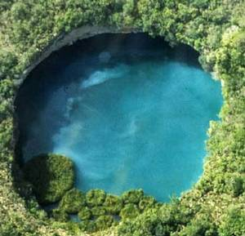
The Chicxulub Extinction Event Crater
What Forces interact to form craters?
No matter at what angle it makes contact, the enormous amount of kinetic energy the projectile carries immediately transfers to the target rock it hits, triggering powerful shock waves. Although craters look like imprints of a giant fist smashing the ground inward, impact shock waves have the opposite effect, which planetary scientists divide into three phases.
The compression stage of crater formation involves that initial exchange of energy between the projectile and the impact area. During the excavation phase, the massive shock wave causes the projectile to simultaneously melt and vaporize, spewing plumes of searing hot rock vapor miles high into the atmosphere. The force can catapult chunks of molten and solid rock hundreds of miles from the impact site — this material is known as ejecta flow.
And so far, the crater formation process has only lasted a few seconds. During the final modification phase, the remainder of ejecta partially refills and rings the crater site, and debris forms a rich mineral composite called breccia. Larger, more forceful impact events will form complex craters in which the rock at the center of the crater rebounds from the downward pressure of the shock wave and uplifts into a mound-like formation.
