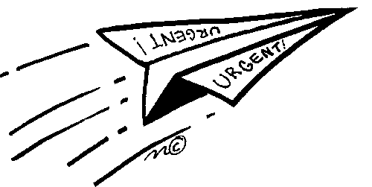

**Paper Airplanes and the Scientific Method**

John Collins, the “Paper Airplane Guy,” studied origami and aerodynamics in a quest to design the world’s most sophisticated paper projectiles. His record-breaking plane flew 226 feet. To Collins, paper airplanes are not just for making a ruckus in class, they can teach us a lot about science. But class disruption is an added bonus! Your goal is to beat Collins record! You want to make the best paper airplane in the world!

**Part 1: Identify a problem.**

In this activity we want to discover which paper airplane design is the best. Today we are going to measure the best paper airplane by how far the paper airplane flies. Please restate your question below.

**State your question________________________________________________________________**.

**Part 2: Gather information.**

Within your group discuss paper airplanes. What do you already know about them? Do you already know how to make them fly further? **Write 3-5 notes here:**

______________________________________________________________________________________________________________________________________________________________________________________________________________________________________________________________________________

**Part 3: State a hypothesis.**

Draw a sketch of your paper airplane design, what about it will make it the best plane? (I have designs if needed, to get you started)

**State and sketch your hypothesis.**

**Part 4: Test the hypothesis.**

When conducting an experiment scientist must choose what they are going to test. We are testing which model airplane flies the furthest. An *independent variable* is what you, the scientist will change. (In our case, the design of the airplane) A *controlled variable* is what the scientist does not change so that they can be sure that the results of the investigation are due to the change in the one variable that is tested. The procedure is partially done for you.

1. You and your table partner will create one paper airplane, while the other two groups at your table will design two different planes. Please identify below which group is designing which airplane (delta, arrow, classic dart or your own design)

Group __________________________is designing (name of your design)______________________

Group __________________________is designing (name of your design)______________________

Group __________________________is designing (name of your design)______________________

* 1. Make your paper airplane.
  2. Throw the first airplane.
  3. Measure the distance it flew and record.
  4. Repeat steps 2-4 three times

**Data table**

|  |  |  |  |  |
| --- | --- | --- | --- | --- |
| Type of Airplane | Trial 1(distance) | Trial 2 (distance) | Trial 3 (distance) | Average Distance |
| 1. |  |  |  |  |
| 2. |  |  |  |  |
| 3. |  |  |  |  |

**Part 5: What modifications or corrections could you make to your paper airplane? With your table partner, make those modifications or corrections. Repeat steps 2-5 and record your data.**

|  |  |  |  |  |
| --- | --- | --- | --- | --- |
|  | **Trial 1** | **Trial 2** | **Trial 3** | **Average** |
| **Airplane 1** |  |  |  |  |
| **Airplane 2** |  |  |  |  |

**Part 5 analyze your data.**

**Answer the following comprehension questions by analyzing your data. (Complete sentences with a restate)**

1. What were the independent variables in this experiment?

______________________________________________________________________________________________________________________________________________________________________________________________________________________________________________________________________________

2. What was the dependent variable in this experiment?

______________________________________________________________________________________________________________________________________________________________________________________________________________________________________________________________________________

3. What was the controlled variable in this experiment?

______________________________________________________________________________________________________________________________________________________________________________________________________________________________________________________________________________

4. How many trials did you complete during this experiment? Why do scientists complete several trials in one experiment?

______________________________________________________________________________________________________________________________________________________________________________________________________________________________________________________________________________

**Part 6: Conclusion**

Was your hypothesis correct? Which of your personal airplanes flew the best (airplane 1 or 2)? Did your first “failure” help you build a successful plane?

______________________________________________________________________________________________________________________________________________________________________________________________________________________________________________________________________________