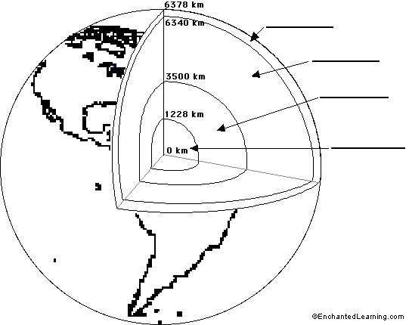

**Directions:**

1. Label the following

-Inner core -Mantle -Lithosphere (orange 280)

-Outer core -Crust -Asthenosphere (orange 280)

2. Color each layer a different color (Make the colors related to the temperature of that layer)

Make a key below.

**Earth’s Interior**  Name ____________________

Date ____________________

Hour ____________________

**Directions: Complete the back side of this assignment. When you are finished answer the following questions using complete sentences and a restate.**

1. Explain how P-waves and S-waves are used to determine the properties of Earth's core.

2. Differentiate between the speed of waves through hot and cold material.

3. Using the seismogram in Figure 19.8 suggest why surface waves cause so much damage even though they are the last to arrive at a seismic station.

4. According to the text what is the upper mantle, inner and outer core made of?

5. RESTATE the definitions of seismometers and seismogram.