AURORAS
Posted on June 16, 2014 by KIDS DISCOVER
It is September 2, 1859. There are no cell phones and no telephones. There are no devices for long-distance communication except telegraphs — machines that send and receive messages along a wire by making and breaking an electrical connection.
On this particular night, the orange hues of the New England sunset do not fade into the usual dark blue of evening. Instead, the night sky glows with brilliant shades of red, as if reflecting the flames of a fire. Streaks of color shoot through the crimson sky in a display so bright you can read the newspaper by its light.
The atmosphere is alive with electricity, literally. Telegraph transmissions fade in and out. Communication is nearly impossible until two operators — one in Portland, Maine, the other in Boston — come up with a solution. They turn off the electricity that powers their machines. For the next two hours they send and receive messages using only the electric “wire” in the atmosphere.
Amazing.
But how could it be so? Was it magic? Divine? Celestial?
No. It was electrons, oxygen, nitrogen, and energy.
It was an aurora.
The Story
Auroras are light displays that take place high in the atmosphere. The bottom edge of an aurora may be 60 miles high. The aurora itself may extend 200 or more miles upward. Many auroras resemble curtains swaying in a breeze; others look more like crowns of light.
Auroras in the northern hemisphere are referred to as the northern lights or the aurora borealis — aurora for the Roman goddess of dawn and borealis, after Boreas, the Greek god of the north wind. Auroras in the southern hemisphere are called the aurora australis, or southern lights.
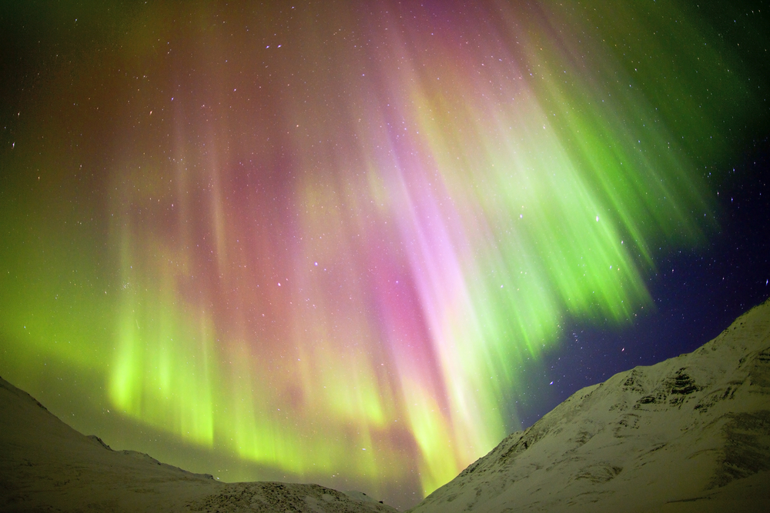
The Why and How Behind the Story
An aurora is the result of collisions between particles from the sun’s solar wind and atoms in Earth’s upper atmosphere.
Let’s start with Earth. It’s no coincidence that the terms North Pole and South Pole refer to places on Earth as well as opposite ends of a magnet. With its iron core, Earth has what amounts to an enormous bar magnet buried deep inside. Like all magnets, the magnet inside Earth produces a magnetic field. Earth’s magnetic field, called the magnetosphere, reaches about 35,000 miles into the atmosphere. Its strongest points are at the poles. (Know that Earth’s magnetic poles and Earth’s geographic poles are not the same. For example, Boston is at magnetic latitude 51.7º N and geographic latitude 42.3º N.)

Like Earth, the sun also has an atmosphere and a magnetic field. However, unlike Earth’s atmosphere which is mostly oxygen and nitrogen, the sun’s atmosphere is mostly hydrogen.
Because the sun is so hot, some of its atmosphere “boils” away, much like steam streaming up from a pot of boiling water. The movement of electrons and other subatomic particles away from the sun’s surface is a phenomenon that scientists call solar wind.
The electrons and other particles that make up solar wind stream through space at about 1 million miles per hour. Some reach Earth’s magnetosphere. Once there, they travel along the lines of Earth’s magnetic field toward the poles. As the particles move, they gain energy and crash into oxygen and nitrogen atoms. The collisions cause the atoms to give off energy in the form of light.
The lights form an aurora. The electrons traveling on the lines of Earth’s magnetic field produce a flow of electricity, which is what powered the telegraph machines on the night of September 2, 1859.
The colors of an aurora depend on the atoms involved. Oxygen atoms high in the atmosphere give off a brownish-red light. Those closer to Earth give off a green light. Nitrogen atoms give off a red or blue light.
The When and Where
Auroras are most common during spring and fall, and last between 60 and 90 minutes. The best time to see them is around midnight when the sky is darkest.
Most auroras take place within a ring around the magnetic pole. That means, if you want to see one, go north, way north, like northern Greenland, Siberia, Scandinavia, and northern Alaska. Or go south, way south, like Antarctica and the southernmost tip of Australia.
During times of severe solar winds, however, auroras may be visible far out of their normal range. On that September night in 1859, during one of the most powerful solar storms in recorded history, the aurora was visible as far south as Panama.
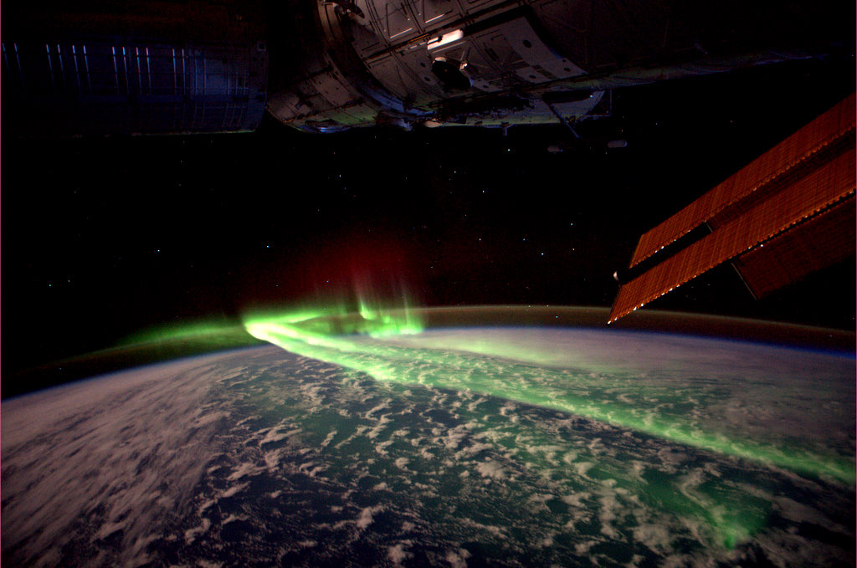
This photo of an aurora was taken from the International Space Station. (André Kuipers / ESA)
Earth is not the only planet in the solar system to have auroras. In fact, all planets have auroras, even those without a magnetic field. All that is needed for these light shows to take place is some sort of atmosphere and a bombardment of high-energy particles. When no magnetic field is present, auroras still occur, but they are less organized. Saturn and Jupiter have auroras similar to Earth’s. Auroras have also been observed on Neptune and Uranus. Venus and Mars have very irregular auroras because they have no magnetic fields

Answer the following using complete sentences with a restate.

1. In your own words define an aurora.

2. What are auroras in the northern hemisphere referred to as?

Southern hemisphere?

3. Describe Earth's magnetic field in at least 3 sentences.

4. What needs to come from the Sun to produce an aurora?

5. What colors do oxygen and nitrogen produce during an aurora?

6. If you wanted to see an aurora where would you go and why?

