You are Invited

to the McCollough-Unis

Family Math

Night

When: Thursday, November 2, 2017
Time: 3:30-5:00 Concession Stand will be open
Who: All McCollough-Unis families are invited

Why should I bring my family to Math Night?
You should bring your family to Math Game Night because they will enjoy learning math by playing various games throughout the evening.

Do I have to stay with my child?
Yes, you must stay with your child because it is going to be a blast and you won’t want to miss it! Also, this is a great opportunity for you and your child/children to have a great night out of learning and fun!

Can I win anything?
Yes, you will have a chance to win themed gift baskets. You must purchase raffle tickets to enter.

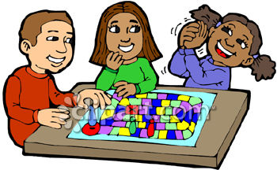

We hope to see you☺

