Interactive World History Notebook (IWHN) Directions Ms. Reda’s Room A128
Things to Remember:
- Number the pages in order. Do not remove any pages, and make sure that right and left-side pages are being numbered. It’s important for all of us to have the same information.
- Any activity that we do that you know will be more than one page MUST be done on a separate sheet of paper and then stapled to the top of the page the corresponding notebook page.
- Helpful hints to great notebooks:
  - Keep your table of contents updated (check it to the one I have in class)
  - Review the information in the notebook daily
  - Use color (highlighters and colored pencils only) to help keep it organized [NO sharpies or markers, they bleed through the paper)
  - Handouts, foldable and other papers should be glued or taped. Use staples only if you are attaching multiple pages of notes.
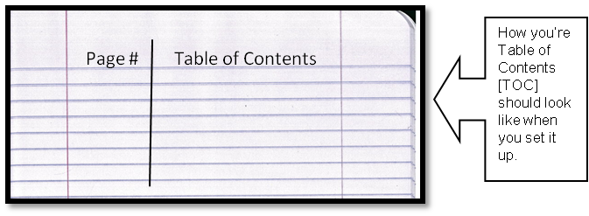
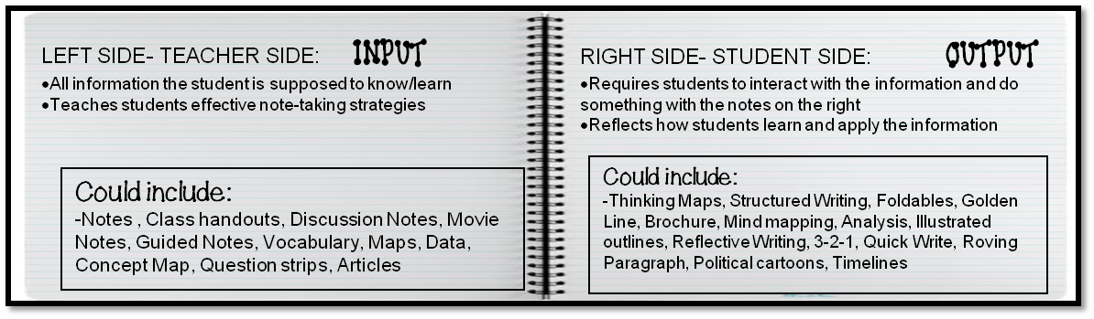
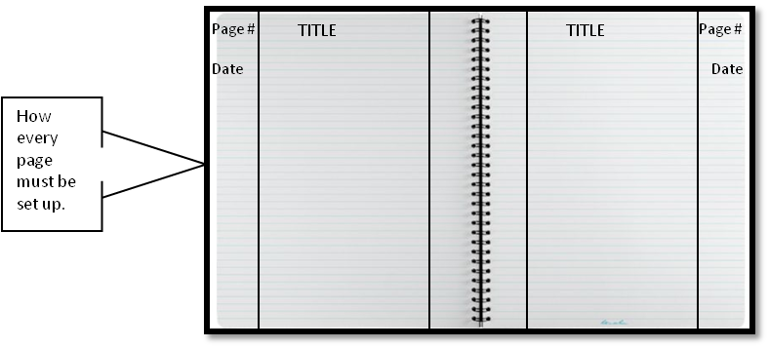
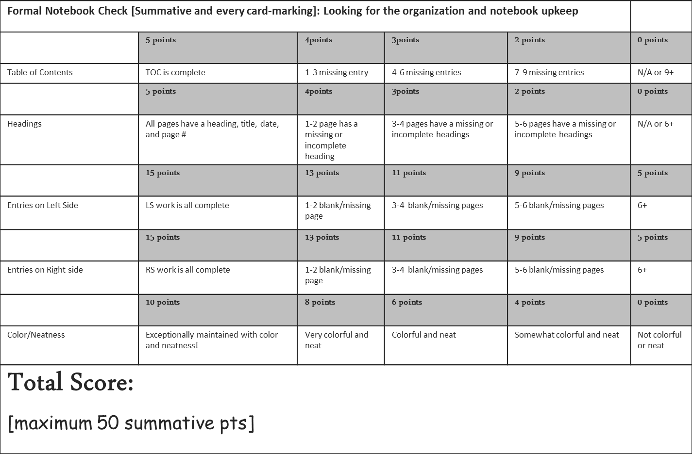
Your notebook will be graded once every card marking:

