Name: ______________________ Hour: ______

**Final Exam Study Guide**

**UNIT 1: SYSTEM OF EQUATIONS**

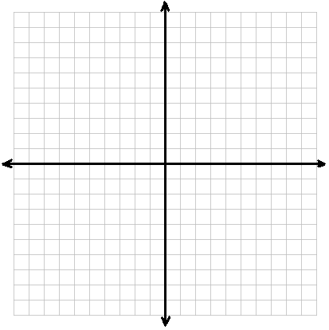

1. **NC** Solve the following system of equations:
$$y=-5/3x+3$$

$$y=1/3x-3$$

2. What method (elimination, substitution, or graphing) would be best to solve this system? Why?
3. Solve the system by graphing.
4. Check your solution.
5. **NC** Solve the following system of equations:
$$y=6x-11$$

$$-2x-3y=-7$$

6. Which method would be the best to use for this system? Why?
7. Solve the system by substitution.
8. **NC** Solve the following system of equations:
$$5x+y=9$$

$$10x-7y=-18$$

9. Which method would be the best to use for this system? Why?
10. Solve by **elimination**.

1. **NC** Graph the following system of inequalities. Then, circle the points below that are solutions to the system.

$$y<-3x-4$$

$$y≥\frac{1}{2}x+3$$

Circle the solutions to the system:

(0, 0) (-4, 3) (-7, 1)

(5, 3) (-2, -3) (-3, -1)

1. **NC** Maria is hosting a party. She places an order at Pizza Hut for 5 pizzas and 4 breadsticks for a total of $51. Halfway through the party, she realizes that she will need one more pizza and 2 more order of breadsticks. This time she was given a total of $15. How much does a pizza cost? How much does a breadstick cost?
2. **NC** Saleh has to buy apples and bananas. A bunch of bananas is $0.30 and an apple is $0.50. He spends a total of $7.00. He bought 3 times as many bananas as he did apples. How many apples did he buy? How many bananas did he buy?
3. Leila has $2 in her purse as coins. She has a total of 16 nickels and quarters. How many coins does she have of each type? Write a system of equations and solve algebraically.
4. For each system below, solve by **two methods**: algebraically and by graphing. Sketch a rough picture of the graph, labeling the solutions clearly.

$y=x^{2}-8x+12$

$y=4x-8$

$y=x^{2}-9x+18$

$$y=x-3$$

**UNIT 2: FUNCTION FAMILIES**

|  |  |
| --- | --- |
| Family: Quadratic  Equation: ______________  https://lh6.googleusercontent.com/Rr5UjrH6hMbGS7jE_M8vEu_I_IVk_NMGyl3mmFabVSHuaRIQ9u4-ha6rVqDzMlj_H4iVjkIF405t59NbDx11S28RRZCQ8tUUOPOlfXEOHvZRS008Xq-AOvnQFm6gPgWXR_SREq-DV0RPS6lZcQ  Domain:  Range:  Positive:  Negative:  Increasing:  Decreasing: | Family: Radical  Equation:  ______________  https://lh6.googleusercontent.com/Rr5UjrH6hMbGS7jE_M8vEu_I_IVk_NMGyl3mmFabVSHuaRIQ9u4-ha6rVqDzMlj_H4iVjkIF405t59NbDx11S28RRZCQ8tUUOPOlfXEOHvZRS008Xq-AOvnQFm6gPgWXR_SREq-DV0RPS6lZcQ  Domain:  Range:  Positive:  Negative:  Increasing:  Decreasing: |
| Family: Absolute Value  Equation:  ______________  https://lh6.googleusercontent.com/Rr5UjrH6hMbGS7jE_M8vEu_I_IVk_NMGyl3mmFabVSHuaRIQ9u4-ha6rVqDzMlj_H4iVjkIF405t59NbDx11S28RRZCQ8tUUOPOlfXEOHvZRS008Xq-AOvnQFm6gPgWXR_SREq-DV0RPS6lZcQ  Domain:  Range:  Positive:  Negative:  Increasing:  Decreasing: | Family: Exponential Growth  Equation: ______________  https://lh6.googleusercontent.com/Rr5UjrH6hMbGS7jE_M8vEu_I_IVk_NMGyl3mmFabVSHuaRIQ9u4-ha6rVqDzMlj_H4iVjkIF405t59NbDx11S28RRZCQ8tUUOPOlfXEOHvZRS008Xq-AOvnQFm6gPgWXR_SREq-DV0RPS6lZcQ  Domain:  Range:  Positive:  Negative:  Increasing:  Decreasing: |

1. Given the family name, find the parent equation and graph it. Determine the domain, range, and end behavior.
2. For the function $f\left(x\right)=a\left(x-h\right)+k$, complete the table for the transformation of each variable and describe them.

|  |  |  |
| --- | --- | --- |
| $$a>1$$ | $$h≥0$$ | $$k≤0$$ |
| $$0<a<1$$ | $$h≤0$$ | $$k≥0$$ |
| $$a<0$$ |

1. Graph the following functions. Find their domain and range.

|  |  |
| --- | --- |
| https://lh6.googleusercontent.com/Rr5UjrH6hMbGS7jE_M8vEu_I_IVk_NMGyl3mmFabVSHuaRIQ9u4-ha6rVqDzMlj_H4iVjkIF405t59NbDx11S28RRZCQ8tUUOPOlfXEOHvZRS008Xq-AOvnQFm6gPgWXR_SREq-DV0RPS6lZcQ  Domain:  Range: | https://lh6.googleusercontent.com/Rr5UjrH6hMbGS7jE_M8vEu_I_IVk_NMGyl3mmFabVSHuaRIQ9u4-ha6rVqDzMlj_H4iVjkIF405t59NbDx11S28RRZCQ8tUUOPOlfXEOHvZRS008Xq-AOvnQFm6gPgWXR_SREq-DV0RPS6lZcQ  Domain:  Range: |
| https://lh6.googleusercontent.com/Rr5UjrH6hMbGS7jE_M8vEu_I_IVk_NMGyl3mmFabVSHuaRIQ9u4-ha6rVqDzMlj_H4iVjkIF405t59NbDx11S28RRZCQ8tUUOPOlfXEOHvZRS008Xq-AOvnQFm6gPgWXR_SREq-DV0RPS6lZcQ  Domain:  Range: | https://lh6.googleusercontent.com/Rr5UjrH6hMbGS7jE_M8vEu_I_IVk_NMGyl3mmFabVSHuaRIQ9u4-ha6rVqDzMlj_H4iVjkIF405t59NbDx11S28RRZCQ8tUUOPOlfXEOHvZRS008Xq-AOvnQFm6gPgWXR_SREq-DV0RPS6lZcQ  Domain:  Range: |

1. For each graph below, determine whether it is a function. Then determine its domain and range in interval notation. Identify **ONE solution to the function (point on the graph)** and **ONE x-intercept.**

|  |  |
| --- | --- |
| Function? YES/NO  https://lh5.googleusercontent.com/JNM8EHiP_SOk-Nu5QlU79Yb3-5s2afOlVHdFT-PTJR-GY4r_IOJGatcRXgbVcPQA0E0-ea_WvobpyZvVme7eX5-Ha_wM1UqBYIQy9umRvbOjGEwhPoXRLq3zzmzq2PjgTgGTl-1n8GOT2rWPdADomain:  Range:  Solution Pt:  x- intercept:  Parent  Function: | Function? YES/NO  https://lh6.googleusercontent.com/XBE4MT1jzwX7HX02bor0tuTBVQWIPhuELvSDrcIT4ZbeBiBxNc6SHKWhXI6JxlPkaFO95szJUI2gH7X9ifz8Dw6uyYnj0UpKO-OPo-c83ciN3V42XuiRwdcnvciusFqzDXjLzhLesYlOD4vsxgDomain:  Range:  Solution Pt:  x- intercept:  Parent  Function: |
| Function? YES/NO  Domain:  https://lh3.googleusercontent.com/ouEnowwzHzfSttK83xc83TBvXbWM_EOu_ZPc1VKLwAZxUefw-V0QwAX60Joo95Ox2EkOP_x4_OUqN29gUrg3EM2ZwaFi_T-F96sQJQi_saWvA4fgwYXfWATzX79lUY5m9vQrCmnDeEifgSpLAwRange:  Solution Pt:  x- intercept:  Parent  Function: | Function? YES/NO  Domain:  https://lh5.googleusercontent.com/YC9bB_soJ0PXtVc6J1Pu9t8stFUJMS_INseN309_qf4AKnbdzUGpn_DHV55fX9_mXAhkakbv2LR_7qpWdYhF-0kwD_8qIa0ag9fjcsF4kH2vQbVGIwjRUz-1Zrplj5Zd9rsfU-KoSNq_MltJiARange:  Solution Pt:  x- intercept:  Parent  Function: |
| Function? YES/NO  Domain:  Range:  https://lh6.googleusercontent.com/M78fzSM05b0h55ElCetfE2fH1UZ_6t8qqF0Cao64HZipD5n2EtNb2pSvpDegZd6Nt1xZ_EH6_ymmqEBCcBF00TeEpc6Bqn3JQ-xu0IXxa3LhBerG2aZy5_-MXKdDmoQFAKQ4fF6VjfUcNvDEUgSolution Pt:  x- intercept:  Parent  Function: | Function? YES/NO  Domain:  https://lh6.googleusercontent.com/bYzw5AI5buwFGegZRhILd8Nvltf-EOkCRvdPOkN6lI6PVE7qsdQ7hduhc-yS-iLKvWbEMbmHsYn87tL3Sp7GlDIBDV-Pq7pdSEUR5rwzDkyJFPkpJd9m82DS0vSF6qs4hE_0nIv1pTE1d4dbWARange:  Solution Pt:  x- intercept:  Parent  Function: |

1. For each graph, draw one line connecting it to its matching **domain** and then fill in the blanks for the **end behavior** to the right of the graph**.**

|  |  |  |
| --- | --- | --- |
| **DOMAIN** |  | **INTERVALS** |
|  | https://lh6.googleusercontent.com/5EzYdQd1uEOj-x31dPUN-jZnwPTaTEEOzyS2Pry0tCAaULANQ0foQxdyoukk4zDxElabeE811bPYZFjk3XcLoG87CNGLwMFy6RsroQev5yE-irLTIWwykyuh8i_tWNqdhN0iO565_B_ib3rtHQ | End Behavior: |
|  | https://lh3.googleusercontent.com/-HtalEsN1dl9kdt2kjuNcjovazPfNKP_VUfrV42fDfUsZ8Xh-HtPhl1fF7c8eaxVoPx2iKAfJT_PgANrA-M7FRN8w2F7VxJp69SAc06DkGQOqespcbJhpTktrCqJ1U6BilmH84jONFtf_tTLmg | End Behavior: |
|  | https://lh3.googleusercontent.com/lfSUMWfOD6FfAj79zlanDGupQGS4CK9ovNlTGfuBnFtoHZFoZHRgm_lRdMdXnNQu_K-wuhp16kgIMJmxlyWZVpVxUr-cji7vQSX1TKdTNLOVM2pN2JASMFhlxW4SHrr88TwtZ_hPN28Ggkviaw | End Behavior: $$x→-∞, y→_____$$ $$x→∞, y→_____$$ |

1. 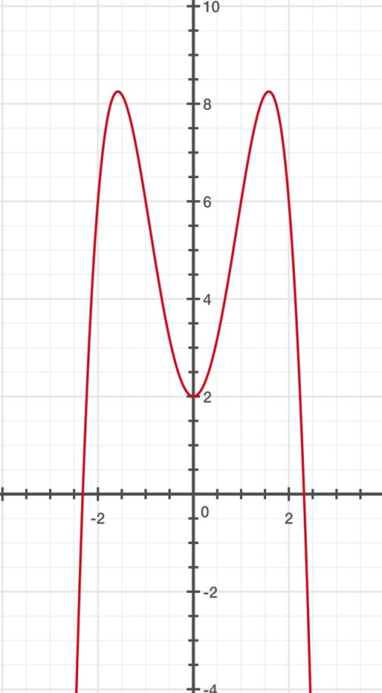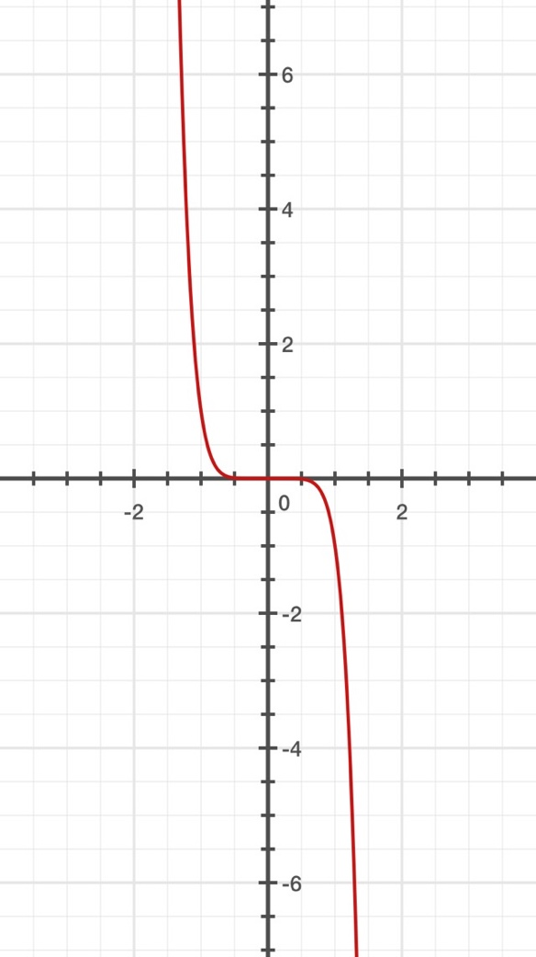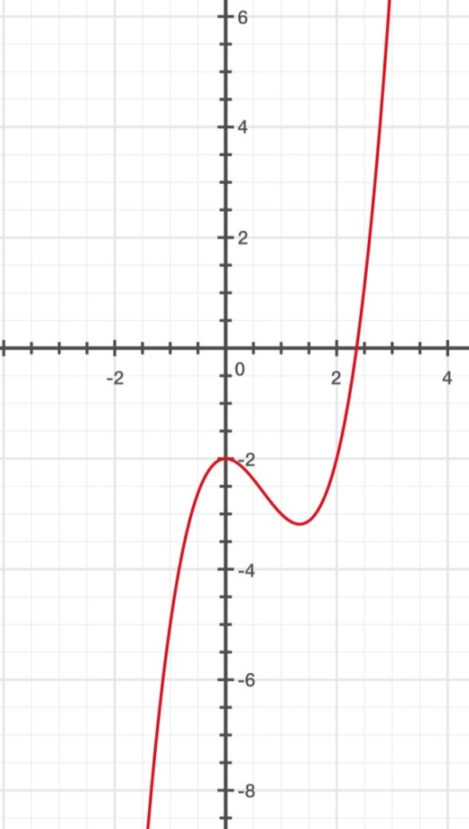Identify the intervals of which the function is **increasing, decreasing or co**

**UNIT 3: QUADRATICS**

1. Simplify the following radicals.
$\sqrt{24}$

$\sqrt{75}$

$\sqrt{-100}$

$\sqrt{45}$

2. 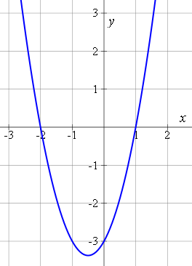Find the **y-intercepts** of the following quadratic functions.
$f\left(x\right)=x^{2}+74x-45$

$f\left(x\right)=x^{2}+4x+23$

$f\left(x\right)=2x^{2}-3x-4$

3. **NC** The graph to the right can be represented by which of the following equations:
$y=\left(x-2\right)\left(x+1\right)$

$y=\left(x-1\right)\left(x+2\right)$

$y=\left(x+1\right)\left(x+2\right)$

$y=\left(x-1\right)\left(x-2\right)$

4. Factor the following functions:
$f\left(x\right)=x^{2}+2x-3$

$f\left(x\right)=x^{2}+8x+15$

$f\left(x\right)=x^{2}-x-20$

$f\left(x\right)=x^{2}+4x+23$

5. Don’t forget that you will have to use the quadratic formula on the final. Please state the quadratic formula and use it to solve for x in the following equations.

$3x^{2}-3x-4=0$ ${11x}^{2}+6x+9=0$

1. How many times does each of the following functions intersect the x-axis?
$y= 3x^{2}+\frac{2}{3}x- \frac{1}{3}$

$f(x)=\frac{4}{3}x^{2}-4x+3$

$y = 2x^{2}-\frac{1}{2}x+\frac{3}{2}$

2. Simplify each expression. Write your answer in $a+bi$ format.
   1. 
$\left(6-2i\right)-\left(11+4i\right)$

$(-2-i)(4+i)$

$(6-5i)(3+2i)$

3. Using the graph at the right, It shows the **height *h*** in feet of a small rocket ***t* seconds** after it is launched. The path of the rocket is given by the equation: $h(x) = -16x^{2}+ 128t.$
4. How long is the rocket in the air? _________
5. What is the greatest height the rocket reaches? ____
6. About how high is the rocket after 1 second? _______
7. After 2 seconds, about how high is the rocket?_________
8. After 6 seconds, about how high is the rocket? _____
9. A quarterback throws a football up into the air with an initial height of 6 feet. The height, *h*, of the ball at *t* seconds can be represented by the equation $h\left(t\right)= -16t^{2}+20t+6.$
   1. How many seconds will it take to reach the maximum height of the football?
   2. What is the maximum height of the football?
10. A squirrel is 24 feet up in a tree and tosses a nut out of the tree. The nuts height, *h,* at time *t* seconds can be represented by the equation $h\left(t\right)= -16t^{2}+8t+24$.
    1. How many seconds will it take for the nut to reach maximum height?
    2. What is the maximum height of the nut?
11. Solve the following for x.

$\sqrt{3x-5}-5=2$

${\left(x-4\right)}^{2}=9$

$4x^{2}+72=0$

$\sqrt{20-5x}=x-5$

**UNIT 4: RATIONALS**

* 1. Simplify the following rational expressions and state the excluded value.
 $\frac{x^{2}-13x+30}{x^{2}+4x-21}$

 $\frac{x+4}{x^{2}+9x+20}$

2. Solve the following rational expressions (find x).

$\frac{5}{2x-3}=\frac{7}{3x}$

$\frac{x+3}{3}=\frac{8}{x-2}$