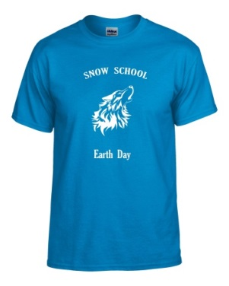

SNOW SCHOOL

Earth Day T-shirts

$6 each

Buy a Snow School Earth Day t-shirt and show your Snow wolf pride at our City Beautiful Parade on May 16th! Shirts are only $6 each. Cash ONLY, please!

*Please turn in orders and money to your child’s teacher by Wed. May 8th.

Please indicate quantity:

|  |  |  |  |  |  |  |
| --- | --- | --- | --- | --- | --- | --- |
| Youth  Small | Youth  Medium | Youth  Large | Adult  Small | Adult  Medium | Adult  Large | Adult  X-Large |
|  |  |  |  |  |  |  |

*Adult XXL $8 *Adult XXXL $9

Student Name: ______________________________________

Teacher: ________________________________ Amount: $________