Unit 2—The Three Worlds Meet

Use the information from your Social Studies notebook as well as the notes below to prepare for our Unit 2 Social Studies test.

**Summarizing Information – Sample Completed Chart**

|  |  |  |
| --- | --- | --- |
|  | **Southwest** | **Pacific Northwest** |
| **Food** | * **Corn** * **Beans** * **Squash** | * **Fish** * **Deer and elk** * **Berries** * **Shellfish** |
| **Houses** | * **Adobe and stone pueblos** * **Single family hogans** | * **Large wooden houses that held several families** |
| **Clothing** | * **Cotton clothing** * **Embroidery on clothing** | * **Clothing of cedar bark** * **Bark rainwear** |
| **Art** | * **Pottery** * **Weaving** * **Baskets** | * **Totem poles** * **Decorated pieces of copper** * **Carved wooden boxes** * **Baskets** |
| **Traditions** | * **Kivas for religious ceremonies** * **Kachinas** | * **Potlatch ceremony** |
| **Other** | * **Irrigated land so they could farm in a dry area** * **Strict rules about water use** | * **Made fishing nets of cedar rope** * **Hollowed out logs for large canoes** |

**Comparing American Indians--Assessment**

**(Sample Answers)**

|  |  |  |
| --- | --- | --- |
|  | **Southwest** | **Pacific Northwest** |
| **How did they adapt to their environment?** | * Built homes using stones and clay bricks since there were few trees * Planted crops deep in the ground for moisture or in flood areas * Stored food surplus * Made clay pots to store food and water | * Hunted and gathered from forests and waters * Used wood from forests to build homes, canoes, totem poles, etc. * Stored food surplus * Built villages near coasts where land was flat |
| **How did they modify, or change, their environment?** | * Dug ditches to irrigate their crops. * Land was used for farming. | * Cut down trees to build homes and canoes * Fished and hunted |

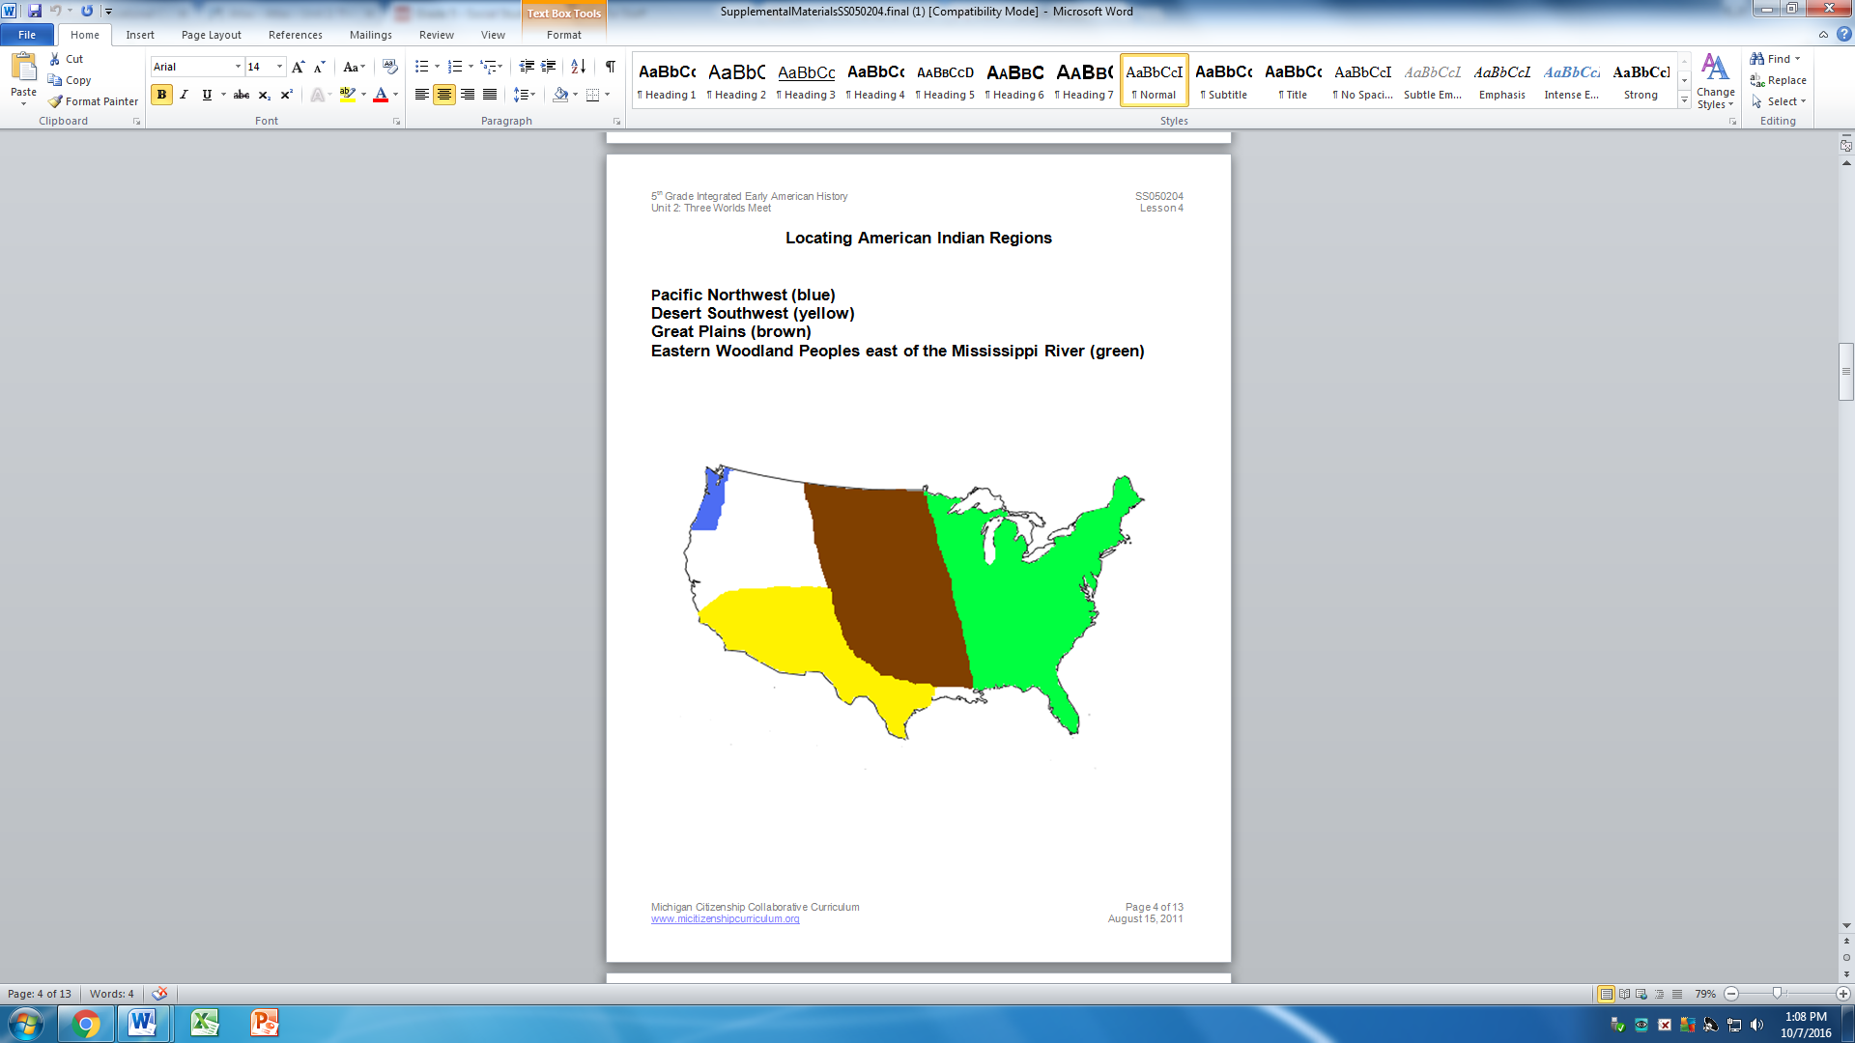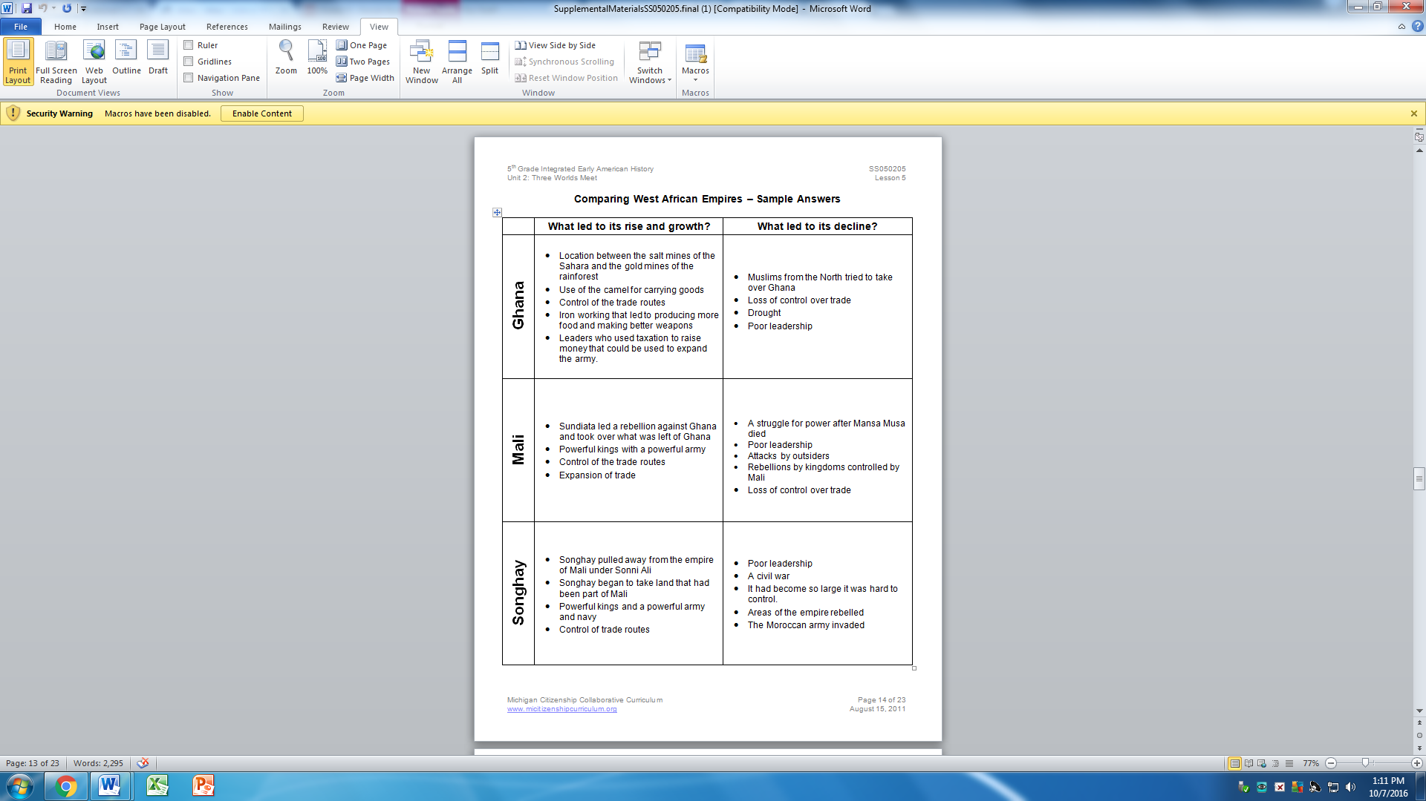

|  |  |
| --- | --- |
| **What are two factors that led to the growth and rise of West African Empires?** | * Location between salt mines and the gold mines * Control of the trade routes * Leaders who used taxation to raise money that could be used to expand the army. * Powerful kings with powerful armies |
| **What are two factors that led to the decline of West African Empires?** | * Loss of control over trade * Drought * Poor leadership * Attacks by outsiders * It was hard to control a big empire |

