**Fun Activities for Students**

1. Interview a family member. (Turn it into a biography with illustrations.)

2. Measure the area and perimeter of each room in your home. Map it.

3. Graph the types of birds that frequent your yard or windows.

4. Be completely silent for 60 minutes, then write about the experience. How did you feel? Was it difficult? Could you go longer without talking and just listening?

5. Write and mail a letter to your teacher, principal, family or friend. Address the envelope yourself.

6. Build a “fable or folktale fort” out of blankets and chairs. Camp in it all day while you create stories to tell your family over dinner.

7. Learn Morse Code or create your own code and use it to communicate with your siblings through walls and floors.

8. Alphabetize the spices (or other food items) in your kitchen.

9. Stay up late and stargaze. Also, check out the moon.

10. Call a grandparent or older relative. Ask them to teach you the words to a song or their favorite book from their childhood days.

11. Design and build puppets then perform a show about multiplication, a poem, a song or a favorite story.

12. Construct a family tree. Ask your family for some help.

13. Learn ten new big words. Write them in marker in fancy writing. Try using them in sentences.

14. Draw a map of your home and neighborhood.

15. Create a Venn Diagram that compares and contrasts two people connected to you.

16. Learn, practice, and perform a magic trick.

17. Learn, practice, and tell three new jokes. ( ex. **What do birds give out on**[**Halloween**](https://www.scarymommy.com/halloween-jokes-and-riddles/)**?** Tweets ; **Why are teddy bears never hungry?** They’re always stuffed!; **What does one volcano say to the other?** I lava you!)

18. Use household materials to make and play stringed, percussion, and wind instruments. Create a song.

19. Collect leaves from ten different (non-harmful) plants. Sort them by size, color, and texture.

20. Put your favorite book, toy, and keepsake on a small table in sunlight. Draw or paint a full color still life.

21. If you have stairs, walk up and count them. Walk down and count by twos. Walk up and count by threes. Continue through tens.

22. Write a poem on your sidewalk using chalk.

23. Classify twenty everyday objects by shape, size, color, height, mass (weight), and material.

24. Measure the length of your bed using five different nonstandard units. (toys, forks, boxes, etc…)

25. Call a person who speaks a language you do not. Ask them to teach you five common words or phrases.

26. Create and use a secret code for writing a message. Share it.

27. Using one type of paper, build 3 different paper airplanes and test to see how far they fly. Have a contest with your family.

28. Set a clock three hours and seven minutes ahead. Whenever someone needs to know the time, help them figure it out by subtracting. (or any special number)

29. Write down every adjective you say for one full day.

30. Color in a map with every state you (or your family) ever visited. Use another color for places you would like to visit. (included)

31. Find ten rocks and sort them by size. Create a rock craft using paints.

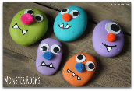 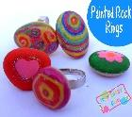

32. Create your own game to play with your family. (ex: Memory, Candyland, Go Fish, Bingo, etc…)

33. Imagine, create, and fly a full size flag that tells the world about you. (use paper, a paper bag, cardboard, etc..)

34. Create an edible science experiment. 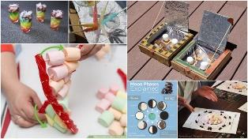

Adapted from: Kim Jones McClelland website: Weareteachers.com dkn