Greetings Henry Ford Families,

We are reaching out to all of you to ask for your assistance with providing a safe environment for members of our Henry Ford School community. Some staff members have serious allergies to fragrances often found in personal care products, perfumes, colognes, lotions, laundry detergents, fabric softeners, scented sanitizer or cleaning products. Contact with these scents, even in small amounts can cause serious and adverse health effects.

As a result, Henry Ford has been designated as a fragrance-free school. As a district, and as a school, we have put in place measures to assist with this situation, and are asking that all the students and staff refrain from wearing scented lotions, colognes, and perfumes, hand sanitizers when in our building. In the event that a student or staff member forgets and wears a scent, they will be asked to wash their hands and call home if a change of clothes is required. The safety and wellbeing of our staff and students is our priority. We sincerely appreciate your efforts to make Henry Ford a designated scent-free school!

Please read the attached chart for examples of items that trigger reactions in our community members with allergies to fragrances. Feel free to contact Mrs. Lamis Srour or Mrs. Mary Timpf if you have questions or would like any additional information about fragrance allergies.

With respect,

Lamis Srour Mary Timpf

Principal Assistant Principal

Henry Ford Elementary School Henry Ford Elementary School

**Scent Free Zones**

Henry Ford Elementary School has been designated a Scent Free Zone because of medical conditions of students and staff members.  By eliminating the use of the items below, you are helping make sure that Henry Ford is a safe environment to learn and work for all staff and students!  Individuals with health concerns have strong reactions to scented items including migraines, breathing problems, shortness of breath, nausea and difficulty concentrating.  Scents can also trigger a severe asthma attack.

**Products to Avoid**

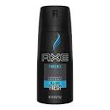  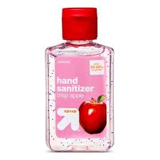   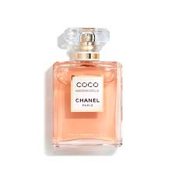                              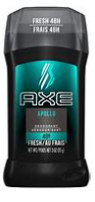             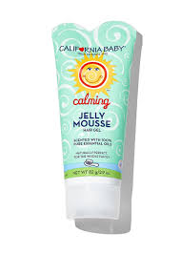                              Perfumes & Cologne                   Scented Hand Sanitizer, Soaps, Lotions & Hair Gels

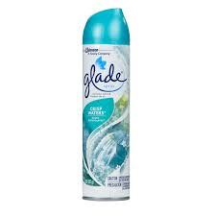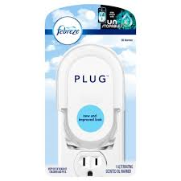              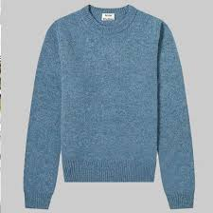

                      Air Fresheners                                         Clothes with perfume smell

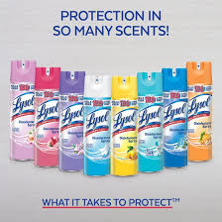

Scented Cleaning Products