Snow City Beautiful Parade

Greetings Families of Snow Elementary School!

We are pleased to announce that we will be hosting the City Beautiful Parade on May 16th at 1:30pm. We invite all parents/ guardians to attend this spectacular event! The parade will begin on Culver St. and end on Houston St. We invite families to help participate in the parade by creating floats and or signs. The City Beautiful floats can be a fun family home project. Here are some examples below! You can use wagons, carts, cardboard.. etc.

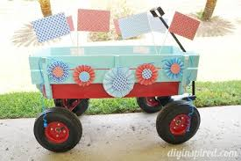

We hope to see you there!

Snow Team

