During WWI the United States as well as almost every other nation involved in the war participated in propaganda advertising to garner (gain) support for the war effort. Propaganda posters, postcards, billboards, movie reels and many other forms of media tried to encourage the people to participate in the war effort in some form or fashion. Propaganda art usually only outlines some of the facts in order to make a point.

WHAT YOU NEED TO DO:
Create propaganda poster that would have appeared at the post office, grocery store, bank or any other public place during WWI. When creating the poster consider the following:
Color: Is it patriotic or just colorful and eye catching?
Words: Who is the poster speaking to…rich intellectuals, small children, or someone in between.
Symbols: Are there any symbols that mean or stand for other things. (e.g. an eagle is a symbol of freedom)
Message: Simple……..what is it going to say?
Audience: Who are you addressing in your poster? Who do you want to be reading this poster?
Purpose: Which branch of the military or government agency is this poster created to support?

HOW TO CREATE YOUR POSTER:
You should start by briefly answering the questions above (jot them down if you need to). On large construction paper or poster board, design an eye-catching picture and slogan. Please make sure that you have both words and some sort of image. You may use printed images with your own creative twist, or images may be hand drawn. Please make sure that they are pertinent to the topic and theme of the poster.

REQUIREMENTS:
- Must work by yourself to complete the poster.
- Must contain at least 1 image.
- Must contain correct information about WWI. (1914-1918)

Examples: These are examples for you to use as inspiration. DO NOT COPY THESE POSTERS IN ANY MANNER. Your poster should be your original idea and work.

Worth 50 Summative Points
Due by the end of the day Wednesday October 28, 2015

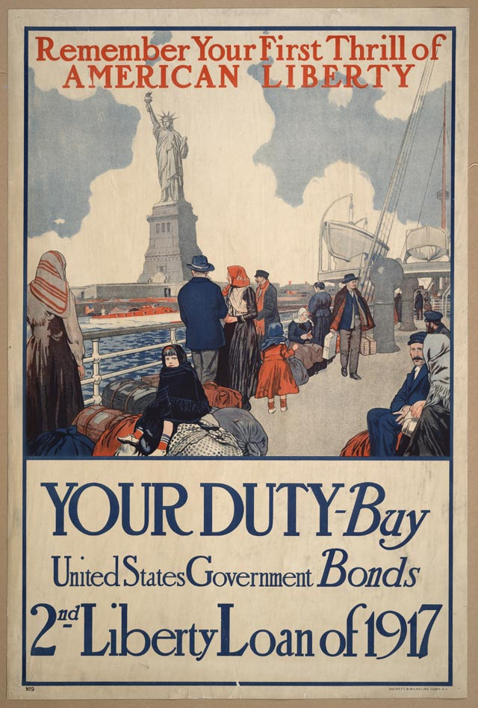 | 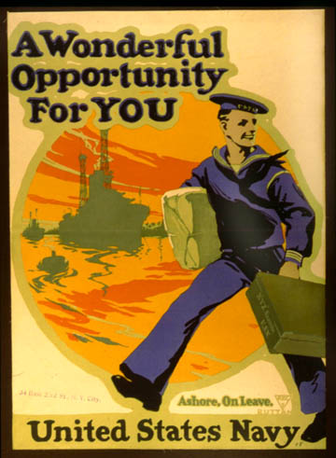 | 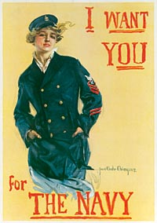
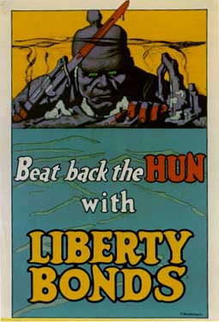 | 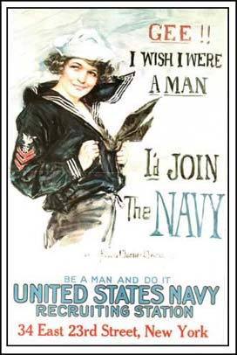 | 