Hammurabi Project Rubric and Examples

This is an individual project in which you will create a Steele or tablet that contains both Hammurabi’s code and a code of your own. Also, you will need to include a two paragraph paper that addresses who Hammurabi was and his influence as a leader. As well as, a paragraph about the empire he ruled.

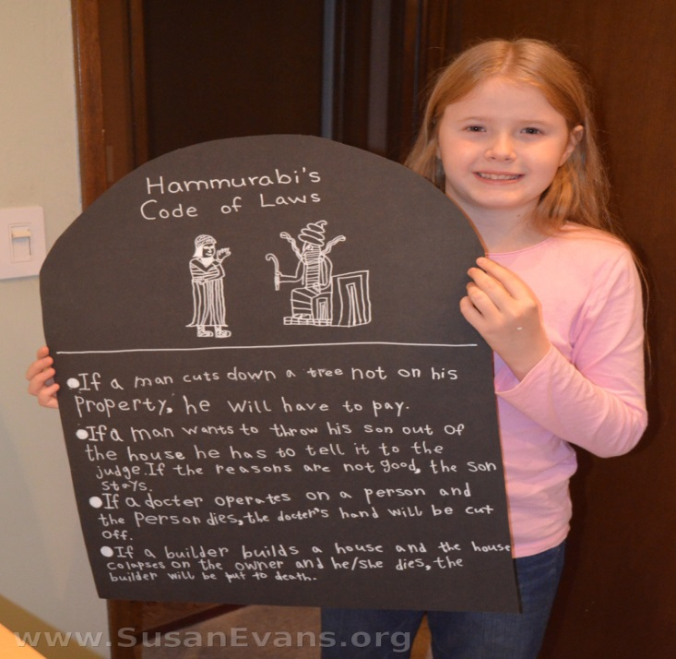I have included some example pictures.

* This is an example; obviously your project will include more laws.
* 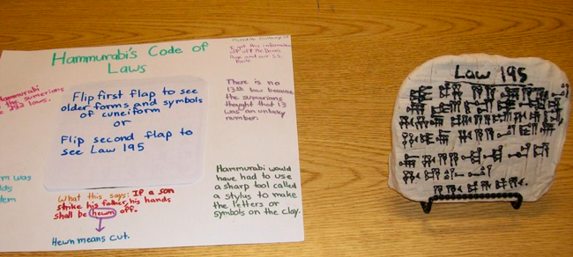 The second example is a clay tablet written in cuneiform (it’s made up cuneiform obviously)—Included is the students description of those laws.

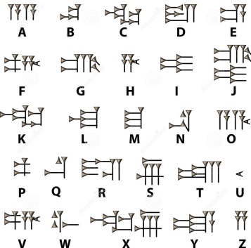

* This is a cuneiform alphabet that can be used to write all the laws or some of them. It can be used as a key to read the code of laws.

***Rubric (20 Summative points):***

Project is due Tuesday, Jan. 24th.

* Project must include some form of a 3d model of Hammurabi’s code of laws, whether it be a poster board, clay, cardboard, I’ll leave that up to you. _____ 5 points
* Must have at least 10 laws, 6 of which must be from Hammurabi’s actual code of laws (can be found online) the other 4 laws made up by you. ­­­­____ 5 points
* 2 paragraph description. The first paragraph about Hammurabi (brief biography), the second paragraph about the empire he ruled. ____ 5 points (2.5 points per paragraph)
* Overall creativity and presentation (look) of the project. ____ 5 points
* BONUS: For projects that go beyond the rubric and show extra thought and creativity. ____ 3 points