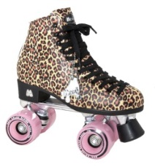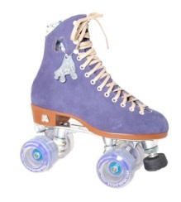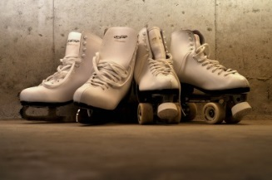

***SAVE THE DATE FOR THE SMITH SPIRIT SKATE!***

**Sponsored & hosted by our O.L. Smith PTSA**

**ON TUESDAY, FEBRUARY 27, 2018**

**6 p.m. to 8 p.m.**

**At the Lincoln Park Skate Center**

**1419 Southfield Road**

**Lincoln Park MI 48146**

**(313) 381-7465**

**The Cost is $8 Admission & Includes Skate Rental**

**(And, only $7 if you are wearing Smith Gear!)**



***\*\*\*Viking Pop Sockets will be available for the first time at this event!\*\*\****

***$6 each or 2/$10 – Find a friend and plan to buy 1 for each of you!***