Example Supply Graphs
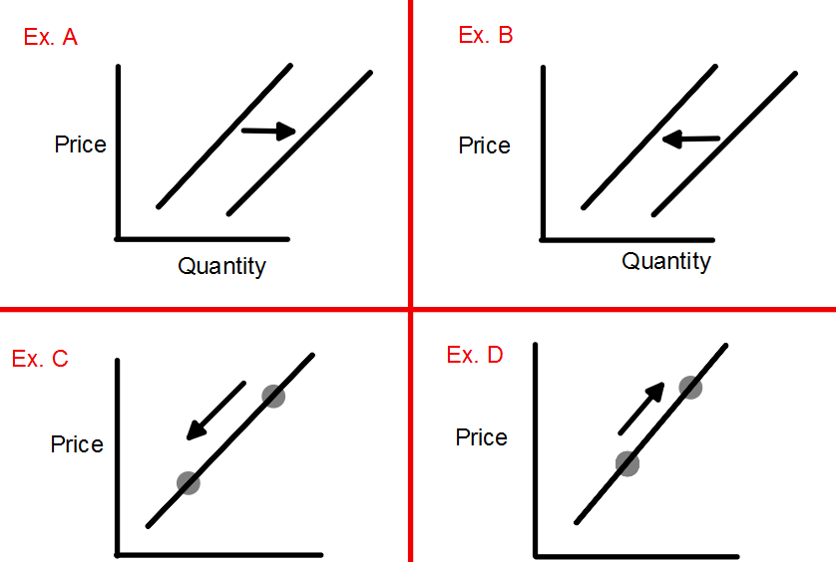

Example A: Increase in Supply Example C: Decrease in Quantity Supplied
Example B: Decrease in Supply Example D: Increase in Quantity Supplied

What causes changes in QUANTITY SUPPLIED? Only a change in the PRICE of the product will cause a change in QUANTITY SUPPLIED.
(A change in Quantity Supplied s is shown as MOVEMENT ALONG the Supply Curve)
What causes changes in SUPPLY? Changes in the factors that cause a change in SUPPLY: (A change in Supply results in a SHIFT in the Supply Curve)
As a producer consider how these factors effect your cost of production or productivity. If any of these factors cause costs to increase or production to decrease then you will have a decrease in Supply (Shift to the Left). If any of these factors cause costs to decrease or production to increase then you will have an increase in Supply (Shift to the Right).
1. Cost of Resources
2. Productivity
3. Technology
4. Taxes and Subsidies
5. Expectations
6. Government Regulations
7. Number of Sellers

