United States Physical Features Map Labeling

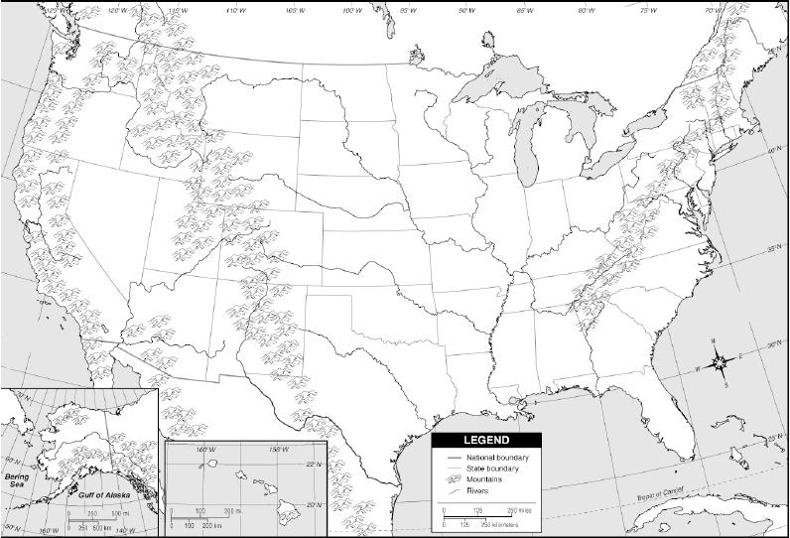

1. On the map above label the following features.
   1. Ohio River
   2. Atlantic Ocean
   3. Pacific Ocean
   4. Great Lakes
   5. Rocky Mountains
   6. Great Plains
   7. Appalachian Mountains
   8. Coastal Plains
   9. Mississippi River
   10. Rio Grande River
2. Color the map.
   1. Rivers should be traced in blue
   2. Mountains should be shaded in brown
   3. Plains should be shaded in green
   4. Oceans and lakes should be colored blue.