7th GRADE SCIENCE  7th grade science consists of Earth Science, Physical Science and Life Science. Students will be completing activities, experiments and readings to promote scientific understanding.  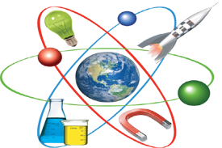  This is the first year students will be learning science using the Mi-STAR Curriculum. The Mi-Star Curriculum allows students to become solution builders as they use science and engineering practices to address real-world challenges spanning each unit. | OCR DISCLAIMER  Dearborn accepts a parent’s assertion that he or she needs language assistance without requiring additional corroboration.  مدينة ديربورن توفر عند الحاجة خدمات الترجمة للأهالي  If you have difficulty understanding this notification, please call the Bilingual and Compensatory Education office at 827-3007.  ALBANIAN: Ju lutemi telefononi zyrën e Programit Dygjuhësor në 827-3007 për colo vështirësi në kuptimin e këtij njoftimi.  ARABIC: إذا كان لديك أية استفسارات، الرجاء الاتصال بالمكتب ثنائي اللغة على رقم3007- 827  ITALIAN: Chiamano l’ufficio Bilingual and Compensatory Education 827-3007 se incontrano difficoltà a capire questae nota.  ROMANIAN: Daca nu intelegeti acest mesaj va rugam sa sunati la biroul Bilingual cu numarul 827-3007.  SPANISH: Por favor, llamen la oficina de Bilingual and Compensatory Education 827-3007 se no comprendon esta nota. |   Welcome to 7th Grade Science! My name is Matthew Bailey and I will have the honor of being your child’s science teacher this year. This is my fifth year teaching this class, and my sixth year as a Public School teacher. I wanted to give you a chance to see how my classroom runs and what expectations I have as a teacher. Please, read through this and feel free to contact me through email or blog, provided below.  Thank you,  Matthew Bailey  Email  baileym@dearbornschools.org  Blog  http://iblog.dearbornschools.org/mrbailey/

CLASSROOM EXPECTATIONS  For the science class to run smoothly, it is the expectation that all rules will be followed. Students will make and will review the rules for the class. The PBIS Matrix will serve as a guideline to be followed in class. Students should complete all homework and classwork and should be prepared to learn each day.  CLASSROOM SUPPLIES  In order to be a successful and responsible 7th grade science student, it is recommended that students bring the following items to class everyday:  - Spiral bound Notebook  - 100 page composition notebook  - Pens, pencils, highlighters  - Colored pencils  - Container to hold supplies  - Folder  - Glue stick  - Planner*  *The Bryant Student planner is expected to be with student at all times.  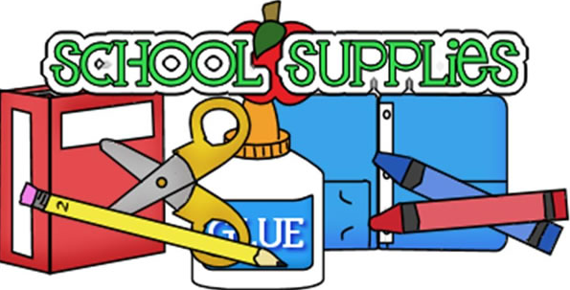 | GRADING SCALE  The following is the grading scale used for this course:  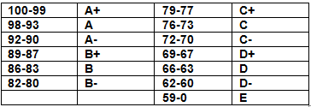  All student grades can be monitored by signing up for parent/student-connect.  RETAKE POLICY  In order to be eligible for the retake, students must have the original test signed by a parent/guardian. All incorrect answers must corrected. All work must be completed on time. Student behavior in class must be not be an issue.  Prior to the assigned retake day students must write a short note explaining why they need a retake and how they will prepare for the retake.  LATE WORK  All work is expected to be completed on time. If work is completed after the due date, grades may be affected. | IMPORTANT DATES  To best keep up to date on your child’s progress in the classroom, please keep in mind the following dates throughout the school year:  OPEN HOUSE:  Wednesday, September 11  6:00 pm - 7:30 pm  PARENT TEACHER CONFERENCES:  FALL  Monday, November 11  Wednesday, November 13  SPRING  Thursday, April 16  MARKING PERIOD END DATES  1st Marking: November 1  2nd Marking: January 17  3rd Marking: March 27  4th Marking: June 12  

