**The Advantages of Plastic Bottles**

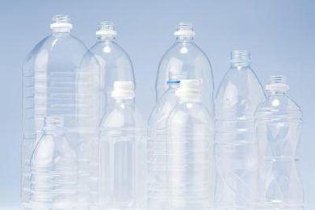

Since the late 1970s, plastic bottles have been widely adopted as packaging materials for beverages, detergent and other consumer goods. Compounds such as polyethylene terephthalate have given plastic bottles several advantages, including toughness, energy savings and ease of production. Plastic bottles are economical to make, safe to use and recyclable.

## Rugged and Safe

Unlike glass containers, plastic bottles are rugged and resilient; they don’t shatter into sharp pieces when dropped, making products and packaging safe to handle. Because plastics are polymers -- long molecules made by linking many short ones together -- they have useful physical properties such as toughness and resistance to chemicals. The same resilience makes plastic bottles unlikely to leak or burst, protecting the contents as well as exterior shipping cartons.

Water placed in sealed bottles have been tested for all kinds of chemicals and bacteria. And because water in bottles are sealed, it has a lower risk for being contaminated with disease-causing germs.

The Competitive Enterprise Institute (CEI) said bottled water goes through special treatments like distillation and ozonation to make water free from impurities. It also offers better and more consistent quality control.

Because the production of bottled water is strictly regulated, you can be sure that water is clean and contaminant-free. This is especially useful in times of natural disasters. Since water lines can be damaged in the event of a calamity, it would be unsafe to drink tap water. Thankfully, there is water contained in clean and sealed bottles that everyone can consume.

## Shapes and Colors

Plastic materials are easy to mold into a wide variety of bottle shapes, improving their appearance and utility. For example, manufacturers incorporate integral handles, measurement marks and pouring lips into some types of plastic bottles. In addition, plastics can range from crystal clear to any shade or color, whether translucent or opaque, making products and brands easy to identify by sight. Plastic bottles require no paint; the coloring material is mixed into the plastic resin, so it never runs, rubs or washes off.

## Energy Savings

Plastic bottles are lighter in weight than their glass counterparts, reducing energy and costs required to ship products. Because plastics are soft and have relatively low melting points, plastic bottles take less energy to manufacture than glass.

## A Recyclable Material

After first use, PET and other types of plastic bottles are easily recycled into many types of secondary products, including carpet fibers, pillow stuffing, tote bags and strapping materials. Some beverage bottles and nonfood containers also use recycled plastic. The light weight of plastic bottles minimizes the cost of transporting materials to recycling centers.

## Emergency Preparation

The Federal Emergency Management Agency recommends that every household set aside at least three days’ worth of bottled water for each member of the family. In an emergency or disaster situation, such as a tornado, winter storm or hurricane, access to clean water may be limited. According to FEMA, a typical person needs about 1 gallon of water per day; a three-day supply would equal 3 gallons. Buy commercially bottled water, store it in its unopened, original containers in a cool and dark place and replace when expired.

For a more serious example of the potential need of water bottles, look no further than Flint, MI. As you are likely aware, the city of Flint had an issue with their water pipes, where homes were receiving water that had traces of the element lead mixed in. Lead (not the kind in your pencil) is extremely harmful to the human body when ingested, causing severe physical and mental problems in those who consume it.

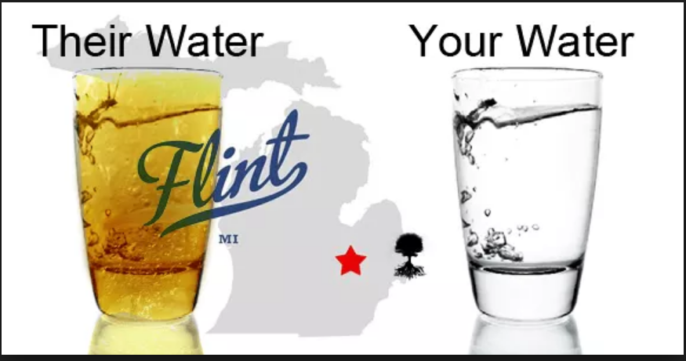

For the people of Flint, clean drinking water from the tap was not an option. This wasn’t an issue with where the water came from, but the pipes under the city that transferred the water to homes. Many other cities in Michigan, and around the country, chose to step up and send water to flint. Easy access to plastic bottled water made for the perfect method of transferring water across the country. People were able to easily pack up trucks filled with water for the people that needed it. This would not have been possible without our readily available plastic water bottles.