Study Guide for Organelles & Microscope Test

Know the different **functions** of **organelles (mitochondria, cell membrane**, etc.) **Remember that cell walls and chloroplasts are only found in plant cells.**

Fill in the blanks for different **organelles**:

1. __________________ is involved in photosynthesis is plant cells.
2. The cytoplasm is the jelly-like fluid that surrounds other organelles in the cell.
3. The _____________ is the “brains” of the cell.

Be able to **label** these items on a picture of a **microscope**:

* Fine focus/Course focus knob ……..these focus the “specimen”
* Stage
* Eyepiece
* Stage
* Base ……. used to carry the microscope safely
* Arm ……. used to carry the microscope safely

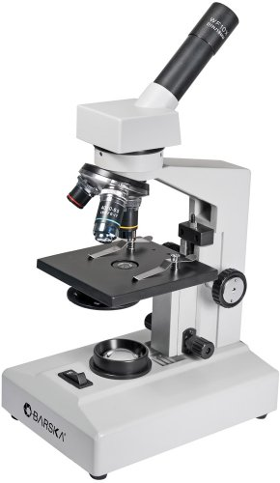

Be able to **label the different organelles of a plant cell**. If your own work is hard to study GO TO: 1.[www.cellsalive.com](http://www.cellsalive.com)

2. Click [Plant/Animal](https://www.cellsalive.com/cells/cell_model.htm)

3. Click 

4. Click Plant Cell