Prophase | 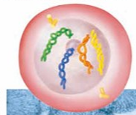 | Mitosis begins. The nuclear membrane dissolves. Chromosomes condense into rod-like structures.
Metaphase | 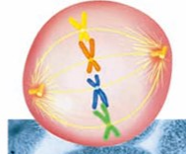 | The Chromosomes line up along the equator of the cell. Homologous chromosomes pair up.
Anaphase | 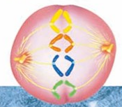 | The chromatids separate and move to opposite sides of the cell.
Telophase | 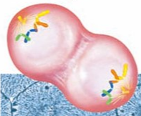 | A Nuclear Membrane forms around each set of chromosomes, and the chromosomes unwind. Mitosis is complete.

