**Cell Theory**

1. Developed over a time period of _______ years.
2. The first scientist to discover and describe cells was __________ __________
3. What are the 3 parts of the ***cell theory?***
4. ________ __________ was the scientist who studied animal cells and also created the first 2 parts of the cell theory.
5. Robert Hooke and Anton van Leeuwenhoek not only helped discover cells, they also helped to develop the __________.

**Microscopes**

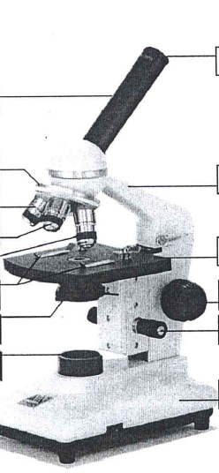

**Cells**

1. _______ are the smallest unit that can perform all processes necessary for life.
2. This part of a cell forms a protective barrier between the cell and its environment.

_____ ______________.

1. Cells can only be created from __________ ________.
2. ____________ is the fluid and almost all of the contents inside of a cell.
3. Organelles are structures in a cell that perform __________ _________.
4. The genetic material needed to make new cells is ________ or deoxyribonucleic acid.