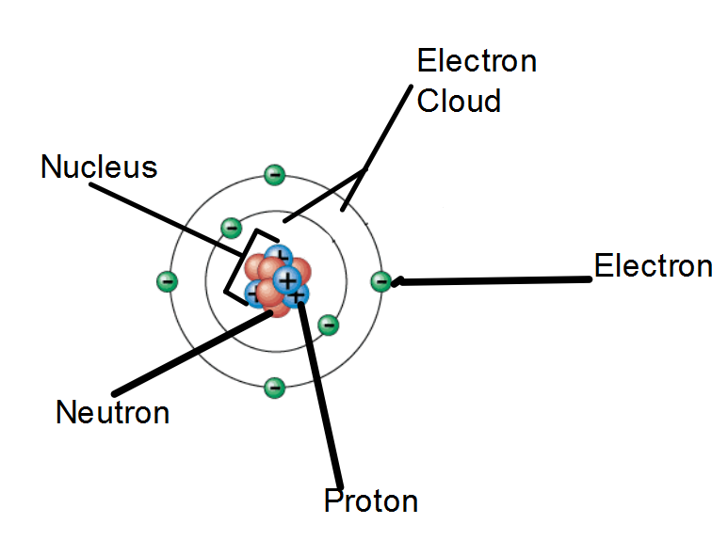

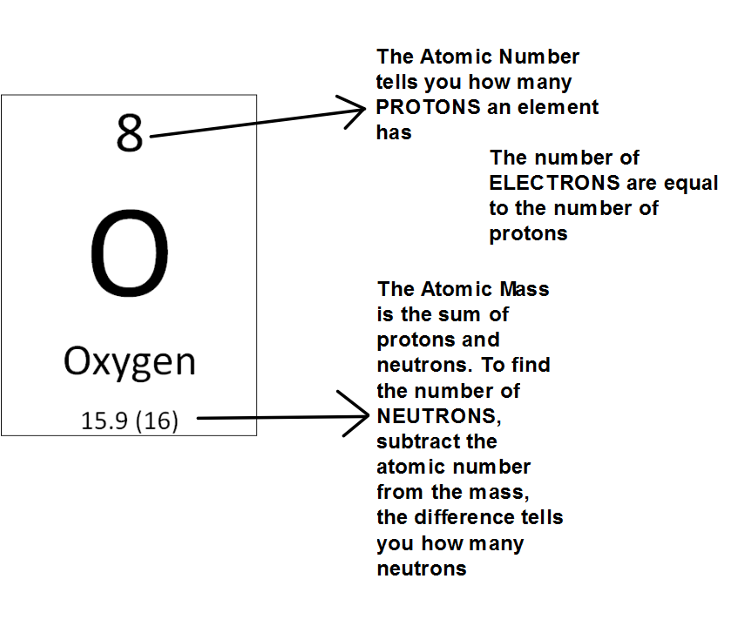

Protons = 8

Electrons = 8

Neutrons: 16-8 = 8