Chapter 7 Review

1. 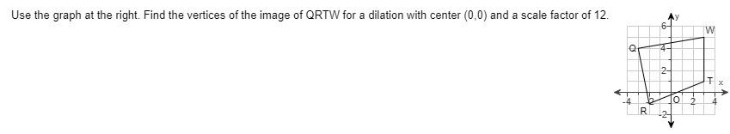
2. 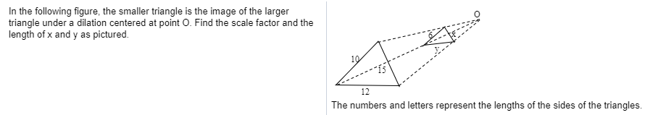

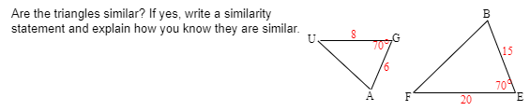

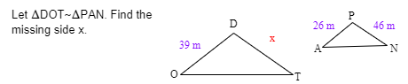

Similar? (Evidence)

Solving for?

Property:

Equation:

Solve:

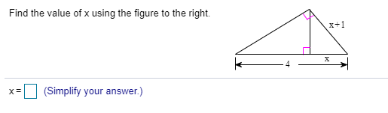

Similar? (Evidence)

Solving for?

Property:

Equation:

Solve:

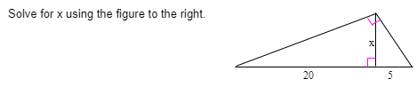

Similar? (Evidence)

Solving for?

Property:

Equation:

Solve:

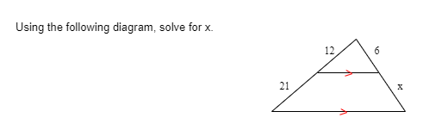

Similar? (Evidence)

Solving for?

Property:

Equation:

Solve:

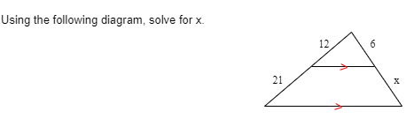8.

Similar? (Evidence)

Solving for?

Property:

Equation:

Solve:

1. 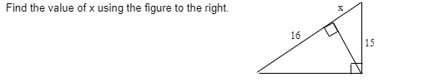

Similar? (Evidence)

Solving for?

Property:

Equation:

Solve:

1. 

Draw a picture and solve

Similar? (Evidence)

Solving for?

Property:

Equation:

Solve:

1. 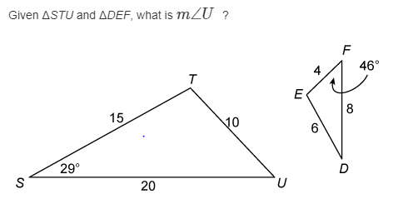

Similar? (Evidence)

Solving for?

Property:

Equation:

Solve:

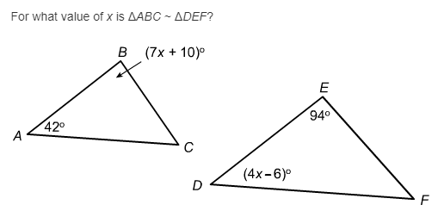

Solving for?

Property:

Equation:

Solve: