Similar Triangles Practice – SHOW WORK Name:________________________________ Hour:______
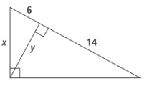  1. Find x and y.  Similar? (Evidence)  Solving for?  Property:  Equation:  Solve: | 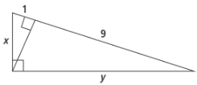  2. Find x and y.  Similar? (Evidence)  Solving for?  Property:  Equation:  Solve:
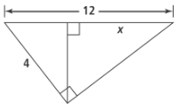  3. Find x.  Similar? (Evidence)  Solving for?  Property:  Equation:  Solve: | 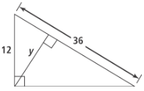  4. Find x.  Similar? (Evidence)  Solving for?  Property:  Equation:  Solve:
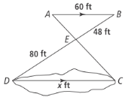  5. Find x.  Similar? (Evidence)  Solving for?  Property:  Equation:  Solve: | 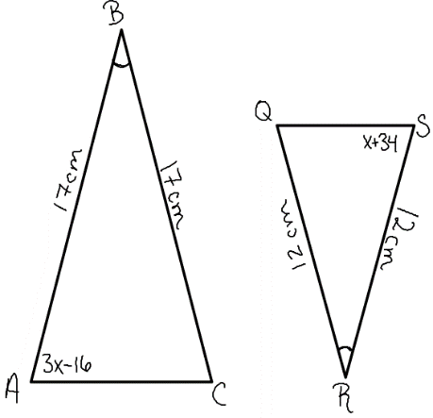  6. Find m<S.  Similar? (Evidence)  Solving for?  Property:  Equation:  Solve:
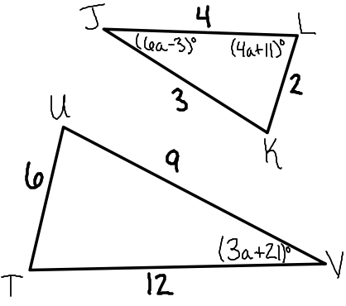  7. Find a.  Similar? (Evidence)  Solving for?  Property:  Equation:  Solve: | 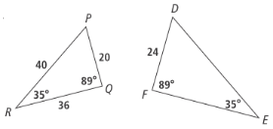  8. Find FE.  Similar? (Evidence)  Solving for?  Property:  Equation:  Solve:

