Section 7-5 Practice – **SHOW WORK** Name:________________________________ Hour:______

|  |  |
| --- | --- |
| 1. Find AD.  Similar? (Evidence)  Solving for?  Property:  Equation:  Solve: | 2. Find x.  Similar? (Evidence)  Solving for?  Property:  Equation:  Solve: |
| 3. Find KL.  Similar? (Evidence)  Solving for?  Property:  Equation:  Solve: | 4. Find x.  Similar? (Evidence)  Solving for?  Property:  Equation:  Solve: |

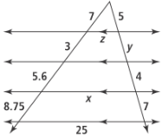5. Find *x*, *y*, and *z*.

Similar? (Evidence)

Solving for?

Property:

Equation:

|  |  |  |
| --- | --- | --- |
| x: | y: | z: |

Solve: