**EnVision Online access information**

1. Go to Dearborn Public Schools website: <https://dearbornschools.org/>
2. Click on Student Portal
3. Click on Google Drive/Docs Login
4. Enter student username and password
5. Click on **Pearson Easy Bridge** and it will take you to the student’s course.





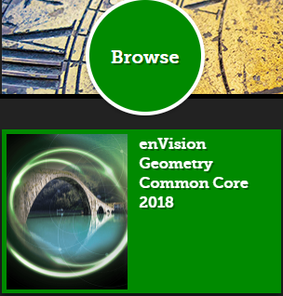

To access the online textbook:



To access any assignments:

When submitting assignments,

be sure to click “Turn In” from

the corner of the task.

Check your % after turning in

each assignment to determine how you did and look into any “Additional Practice” assignments EnVision gives you for extra support at your current level of proficiency.