Proving/Justifying Geometric Statements Review Name:____________________________ Hour:_______

1. ABCD is a trapezoid (one pair of parallel sides). Determine a and b and justify each relation.

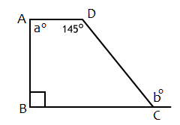

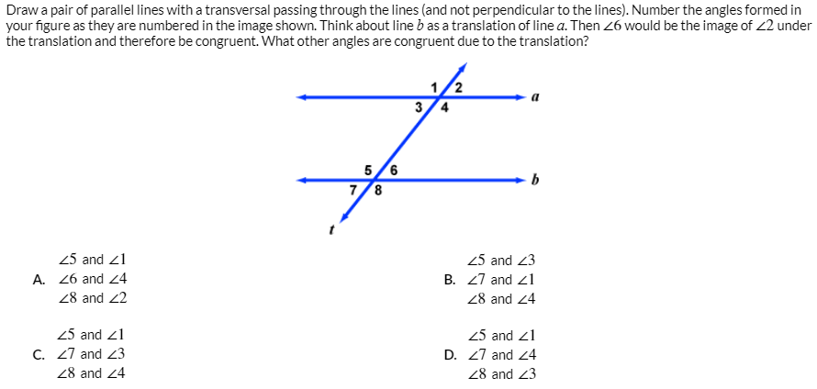

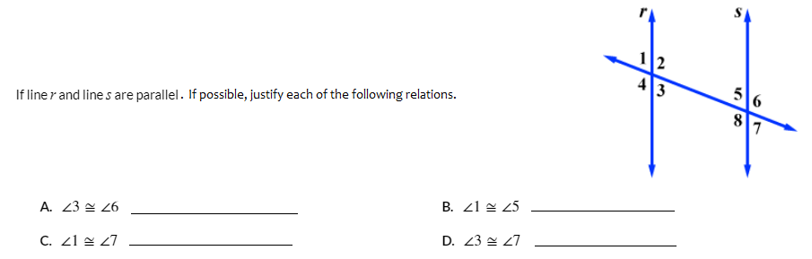

1. 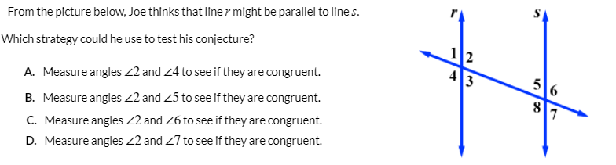
2. 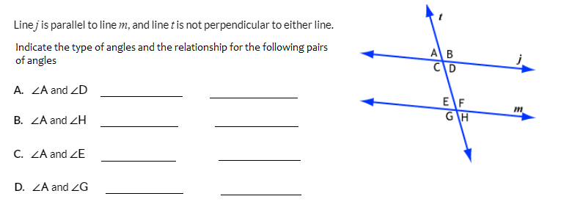
3. 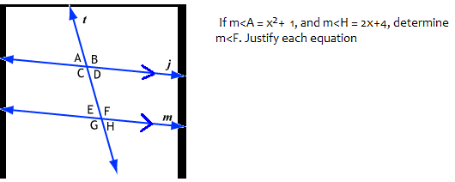
4. 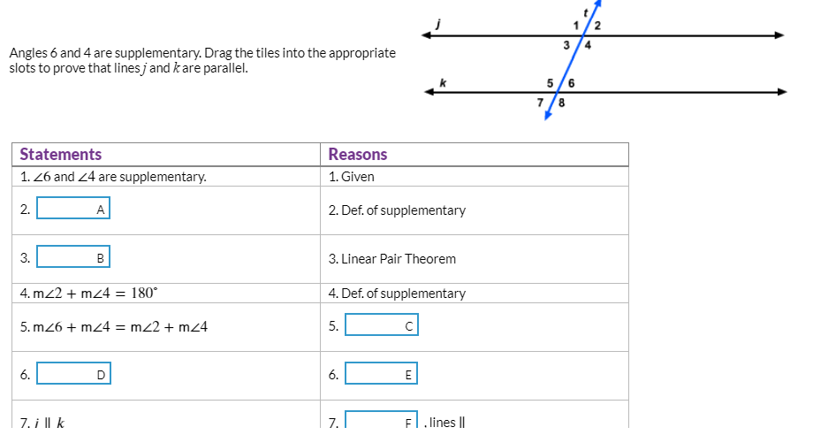

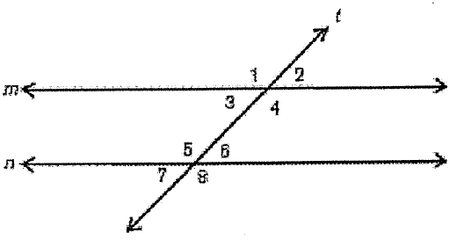

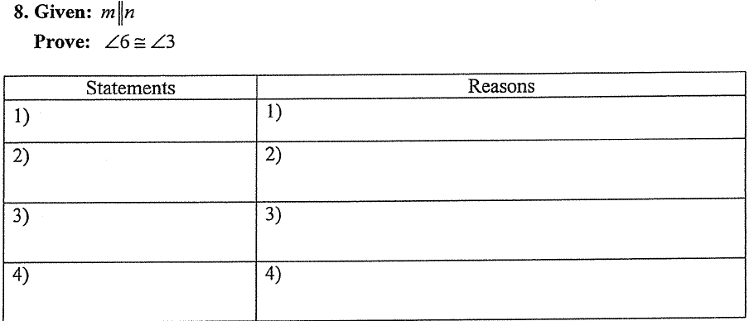

9. Create a proof for the following: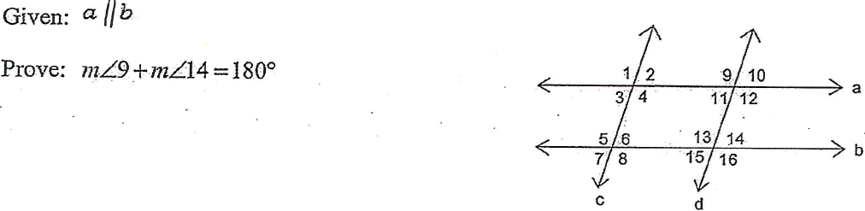

10. Prove the following:

