**Applying Transformations Review Name:_______________________________ Hour:_______**

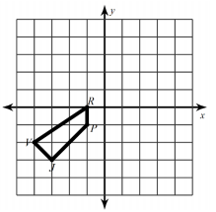1) Preform two different transformations on the given figure RPVJ and write the new coordinates for R”P”V”J”

a-Translate the given picture 3 units right and 4 units up

b- Rotate 180 degrees

2) Write a rule describing the below transformations

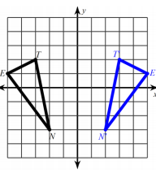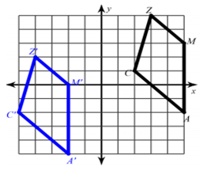

3) Write the rules of the following transformations:

a- Reflect across x-axis ________________________________

b- Reflect across y-axis ________________________________

c- Rotate 180 degrees _________________________________

d- Translate 2 units down and 4 units to the right ______________________________

e- Dilation by a scale factor of 8 ______________________________

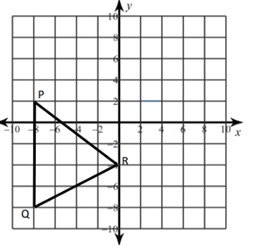4) **Reflect the given image across x = -2**

**5) Reflect the given image across y = -4**

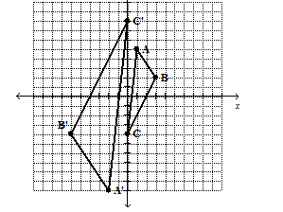**6) Describe the series of transformations preformed in the below picture and write a rule describing them**

7.

