Unit 4 – Prove/Justify Geometric Statements Name:_______________________________ Date:________

1. What kind of reasoning is used to build and support an argument off of true statements?
2. What kind of reasoning is based off of looking at a pattern and thinking something to be true?
3. List the postulate described by the given examples below:
   1. AB + BC = AC _________________________________
   2. m<JKL + m<LKM = m<JKM __________________________________
4. Select all that apply: Once a theorem has been proven, we…
   1. Need to prove it again next time we use it in a proof
   2. Never have to think about it again
   3. Can use it as a “Reason” as many times as we want
   4. Need to prove the converse (that it works in the opposite direction as well)
5. 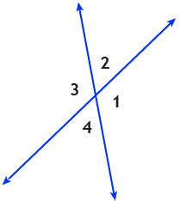Given two intersecting lines as shown in the diagram, which conclusions can be drawn? Select all that apply.
   1. m<1 = m<2
   2. <1 and <3 are vertical angles
   3. m<2 = m<4
   4. m<3 + m<4 = 180°
   5. <2 and <3 are supplementary
6. Fill in the correct reasons for the statements below:

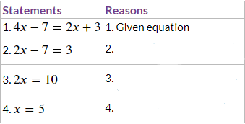

7 – 9. Complete the proofs below.