|  |  |  |
| --- | --- | --- |
| Type of Transformation | Definition in own words | **Labeled** Diagram |
|  |  | Image result for coordinate plane |
|  |  | Image result for coordinate plane |
|  |  | Image result for coordinate plane |

Why is a dilation not a rigid transformation:

_____________________________________________________________________________________

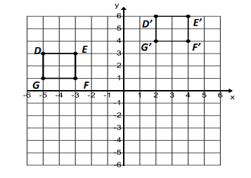

**Characteristics**

**Same size Different size**

**Same shape Different Shape**

**Same Location Different Location**

**Same Orientation Different Orientation**

**What kind of transformation is this?**

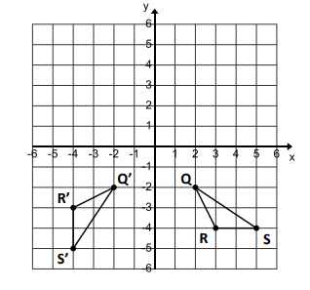

**Characteristics**

**Same size Different size**

**Same shape Different Shape**

**Same Location Different Location**

**Same Orientation Different Orientation**

**What kind of transformation is this?**

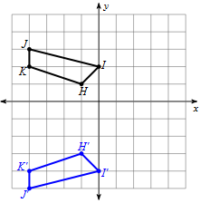**Characteristics**

**Same size Different size**

**Same shape Different Shape**

**Same Location Different Location**

**Same Orientation Different Orientation**

**What kind of transformation is this?**

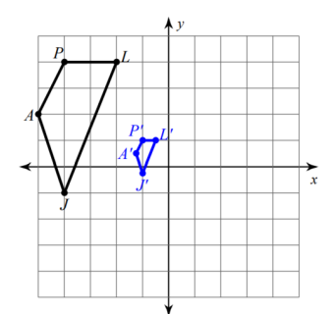

**Characteristics**

**Same size Different size**

**Same shape Different Shape**

**Same Location Different Location**

**Same Orientation Different Orientation**

**What kind of transformation is this?**