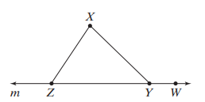

Use the above figure.

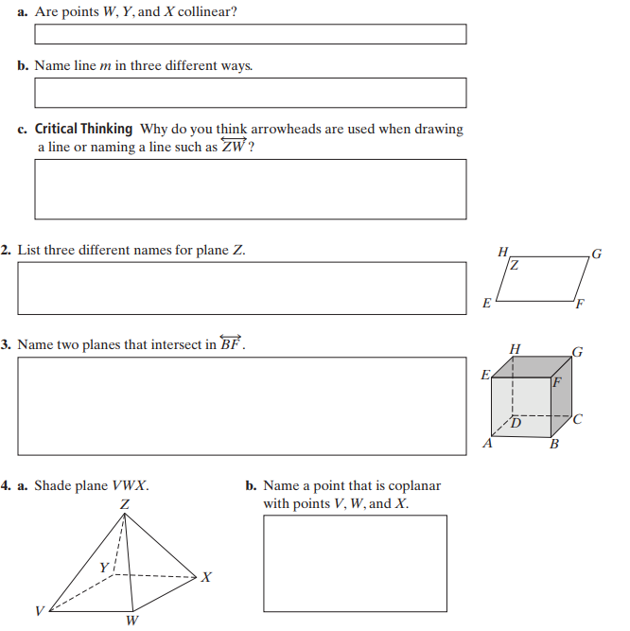**1.**



5. Use the figure above.

a. Name an angle that is not included in the triangle.

b. Name two unique rays.

6. Is the definition below correct? If not, provide a counterexample and rewrite the definition so that it is correct.

A ray is a line that only goes in one direction.

7. Using the below figure, shade the plane containing points H, E, C, and B.

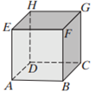

8. Using the above diagram, give an example of 4 points which are not coplanar.