**Name _____________________________**

**In Class Group Assignment Score ___ / 10**

**Vertical Line Test:** This is a special test that can be used to determine if a graph is a function. If you can draw a vertical line so that it intersects a graph more than once, the graph is **NOT A FUNCTION**. If you cannot draw a vertical line that intersects a graph more than once, then the graph **IS A** **FUNCTION**.



1.) { ( - 2, 5 ), ( -1, 2 ), ( 0, 1 ), ( 2, 5 ) }

Does this relation represent a function?

Why or why not?

__________________________________

__________________________________

__________________________________

List the Domain of x: { }

List the range of y: { }

2.) { ( 2, 8 ), ( - 3, -7 ), ( 0, 2 ), ( -1, - 1 ) }

Does this relation represent a function?

Why or why not?

__________________________________

__________________________________

__________________________________

List the Domain of x: { }

List the range of y: { }

Let’s practice looking at graphs and determining if the graph is a function.

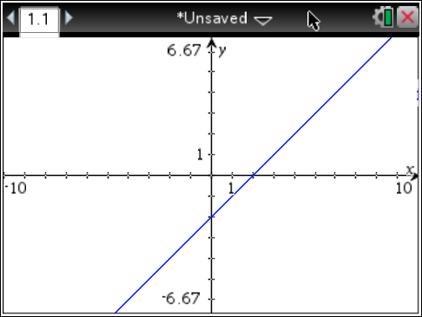3.) Function or Not a Function

Why or Why Not?

_________________________________

_________________________________

_________________________________

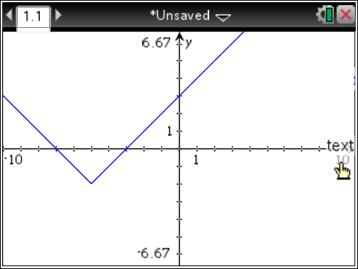4.) Function or Not a Function

Why or Why Not?

_________________________________

_________________________________

_________________________________

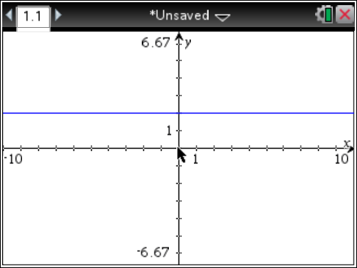5.) Function or Not a Function

Why or Why Not?

_________________________________

_________________________________

________________________________

6) { ( 2, 0 ), ( 2, 4 ), ( 0, 2 ), ( 4, 2 ) }

Does this relation represent a function?

Why or why not?

__________________________________

__________________________________

__________________________________

List the Domain of x: { }

List the range of y: { }

7.) { ( - 3, 3 ), ( -4, 4 ), ( - 3, - 3 ), ( 0, 0 ) }

Does this relation represent a function?

Why or why not?

__________________________________

__________________________________

__________________________________

List the Domain of x: { }

List the range of y: { }

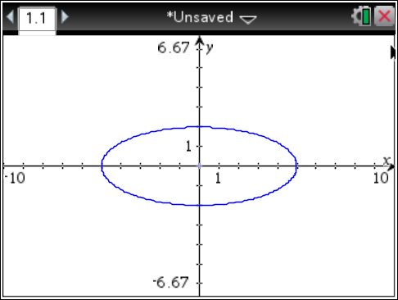8.) Function or Not a Function

Why or Why Not?

_________________________________

_________________________________