Name ________________________________
Determining Function with Tables and Mappings

Partner Activity:
A) and B) Determine if the following are functions:
A) M Tacos B) 3 6
T Fish 4 7
W Hot Dogs 6 9
R Pizza 9
Yes or No Yes or No

Determine if each relation below is a function.
1. 2. 3.
Function: Y N Function: Y N Function: Y N
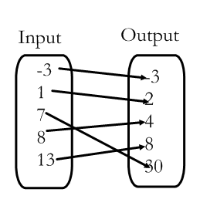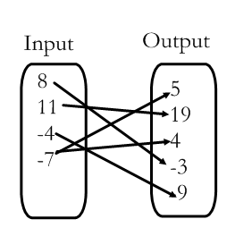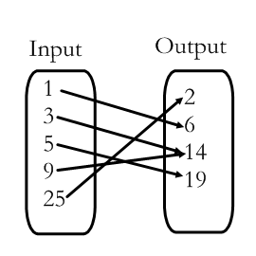
4. 5. 6.
Function: Y N Function: Y N Function: Y N
x | y
-6 | 13
-4 | 18
-2 | 25
0 | 34
2 | 45
4 | 58
x | y
3 | 18
8 | 11
11 | 4
7 | -6
2 | 18
-1 | 21
x | y
-7 | 9
-3 | 11
-1 | -8
6 | 8
-3 | 19
-9 | -10

