STUDY GUIDE

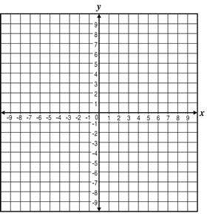Graph the equations. Make sure to show Axis of Symmetry. You must have 5 points graphed.

**1)** y = x² + x – 1 (3 pts)

**2) Factoring**

1) 2x² + 11x + 15 = 0

2) x² + 6x + 5 = 0

3) 5x² + 18x + 8 = 0

4) x² = -6x – 9

5) x² - 5x = 24

**3)** What is the vertex of y= =?

(1) (0,3.5) (3) (0,3)

(2) (0,7) (4) (0,4)

**4) *Find the square.***

1. (2x – 6)2

a. 4x2 -24x +36 b. 4x2 -8x +36 c. 4x2 +36 d. 4x2 -12x +3

2. (8m + 7)2

a. 64m2 +112m – 49 b. 64m2 +112m + 49 c. 64m2 -56m – 49 b. 64m2 -112m + 49

**5)** ***Find the product*.**

1. ( j + 7 ) ( j – 7)

a. j2 + 14j – 49 b. j2 - 14j – 49 c. j2 + 14j + 49 d. j2  - 49

**6) Find the zeros/roots/solutions.**

1. x (x + 9) = 0

**7) Which of these quadratic functions is graphed below?**

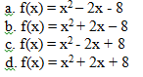

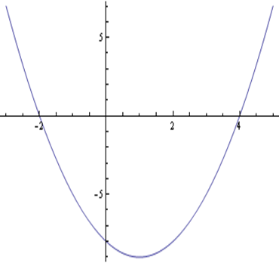

**8) The following is a graph of the path of a rocket after it is launched.**

[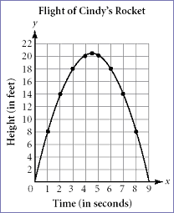](http://www.learner.org/workshops/algebra/workshop8/lessonplan1c.html)

Identify and explain the real world meaning of the following points. Height is in feet and time is in   
 seconds.

a) Vertex b) x-intercept(s) c) y-intercept(s)

**9)** How long does it take for the rocket to reach the **ground**? (Quadratic Formula)

**10)** Tell the x-intercept(s)/zero(s)/factor(s)/solution(s) of:   
 a)  b)    
 c)  d)    
 e)  f) 

**11)** Tell the vertex of each, then tell if the vertex is a maximum or a minimum:   
 a)  b)    
 c)  d)    
 e)  f) 

**12)** Tell the x- and y-intercepts of each:   
 a)    
 b)    
 c) 

**13)** a) What is the vertex of g(x) = (x – 3)2 + 2 ?

Which of the following has the **same vertex** as g(x)? Defend each answer.   
 b) h(x) = -2(x – 3)2 – 2   
 c) f(x) = (x + 3)2 + 2   
 d) p(x) = x2 – 6x + 11   
 e) q(x) = (x – 3)(x + 2)

**Determine the number of solutions for the following quadratic functions in questions 23 and 24.**

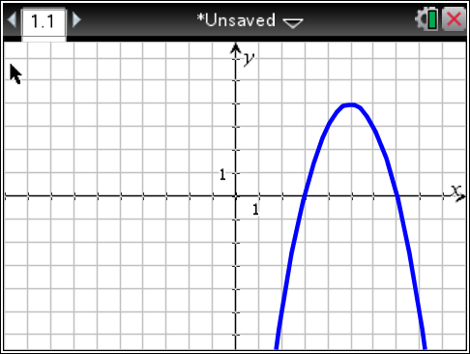**14) 15)**

