**Reflections in the Plane**

**Definitions:**

|  |  |
| --- | --- |
| **Reflection** |  |
| **Reflection over the x-axis** |  |
| **Reflection over the y-axis** |  |

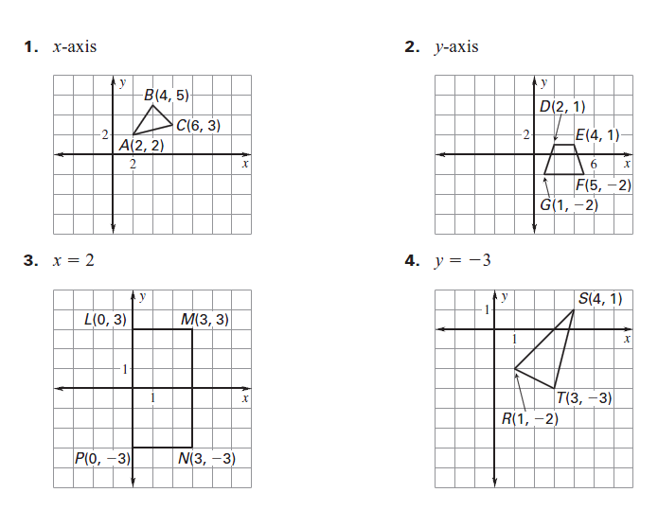**Example 1: Graph the reflection over the given line.**