QUIZ: Reflections, Translations, and Dilations

Name _______________________________________Date_____________Period______

Circle the correct answer for 1-7.

1. A point P has coordinates (-8, -2). What are its new coordinates after reflecting point P across the x-axis?

[A] (-8, 2) [B] (8, -2) [C] (8, 2) [D] (-2, -8)

2. What is the reflection image of (5, -3) across the y-axis?

[A] (-5, 3) [B] (-5, -3) [C] (-3, 5) [D] (-3, -5)

3. A point Q with coordinates (-8, -6) is reflected across the y-axis. What are its new coordinates?

[A] (-8, 6) [B] (8, -6) [C] (-8, -6) [D] (-6, -8)

4. Write the translation of point P(2, -9) to point P’(0,-12).

[A] $\left(x,y\right)→\left(x−3,y−2\right)$ [B] $\left(x,y\right)→\left(x+3,y+2\right)$
[C] $\left(x,y\right)→\left(x+2,y+3\right)$ [D] $\left(x,y\right)→\left(x−2,y−3\right)$

5. The coordinates of the preimage triangle DEF are D (- 4, 5), E (9, -2), F (0, -6). The coordinates of the image triangle D’E’F’ are D’(-8, 10), E’( 18, -4), F’ ( 0, -12) . What is the scale factor from the preimage to the image?

[A] 2 [B] 3 [C] $\frac{1}{3}$ [D] $\frac{1}{2}$

6. Rectangle T’R’S’Q’ is the shrinkage of rectangle TRSQ. What is a possible scale factor of the dilation?

[A] 2 [B] 4 [C] 3 [D] $\frac{1}{2}$

7. Your new T-shirt got smaller slightly when it was washed and dried. What scale factor below could best describe this dilation?

[A] 1.3 [B] 0.9 [C] 0.1 [D] 2.0



8. Graph the triangle whose vertices have the coordinates given below. Then draw its dilation using a scale factor of 2 and the origin as the center of dilation. Be sure to label triangle RST and triangle R’S’T’. (3pts)
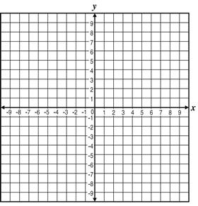
R (1, 4) N (3, 0) P (-1, -3)

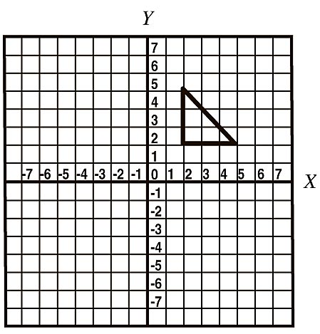
9. Reflect the triangle over the x-axis. (3pts) 10. Translate the following quadilateral MNPQ down 2 units, the left 3 units. (3pts)
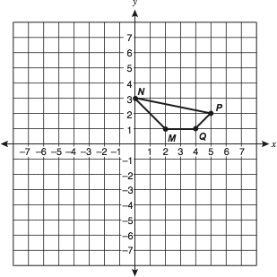

EXTRA CREDIT:

Show the difference between a counter-clockwise rotation and a clockwise rotation.

11. An equilateral triangle is drawn on a coordinate plane. Each angle measures 60°. If the triangle were to be reflected over the y– axis, what would be the new angle measure for this reflected figure?

A. 60°
B. 120°
C. 180°
D. 360°

12. Which sequence of transformations takes ΔA to its image, ΔB?

A. reflection over the x-axis and translation 2 units down
B. reflection over the y-axis and translation 2 units down
C. translation 2 units down and 90° clockwise rotation about the origin
D. translation 12 units right and 90° clockwise rotation about the origin

13.

A. It must be an equilateral triangle with the same side lengths as the original triangle.
B. It must be an equilateral triangle, but the side lengths may differ from the original triangle.
C. It may be a scalene triangle, and all the side lengths may differ from the original triangle.
D. It may be an obtuse triangle with at least one side the same length as the original triangle.

14. A hexagon graphed on a coordinate plane underwent a rotation about the origin, a reflection across the x–axis, a translation up, and a dilation with its center at one of the hexagon's vertices to produce another hexagon. Which of these statements is true about the original hexagon and the new hexagon?

A. They are similar.
B. They may or may not be similar, depending on the scale factor of the dilation.
C. They may or may not be similar, depending on the number of degrees rotated.
D. They are not similar.

15. Given the diagram below, which of the following statements is true?

A. The two figures are not similar because Figure G was dilated by a factor of 3 to form Figure H.
B. The two figures are similar because Figure G was dilated factor of 3, then reflected over line m to form Figure H.
C. The two figures are not similar because Figure G was translated to the right then dilated by a factor of 3 to form Figure H.
D. The two figures are similar because Figure G was dilated factor of 13 , then reflected over line m to form Figure H.

