7. A history teacher asked her students how many hours of sleep they had the

night before a test. The data below shows the number of hours the student

slept and their score on the exam. Plot the data on a scatter plot.

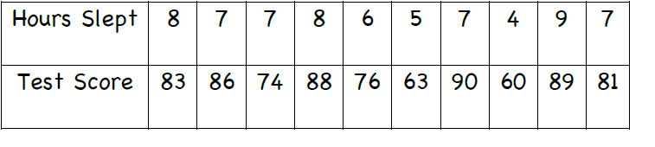

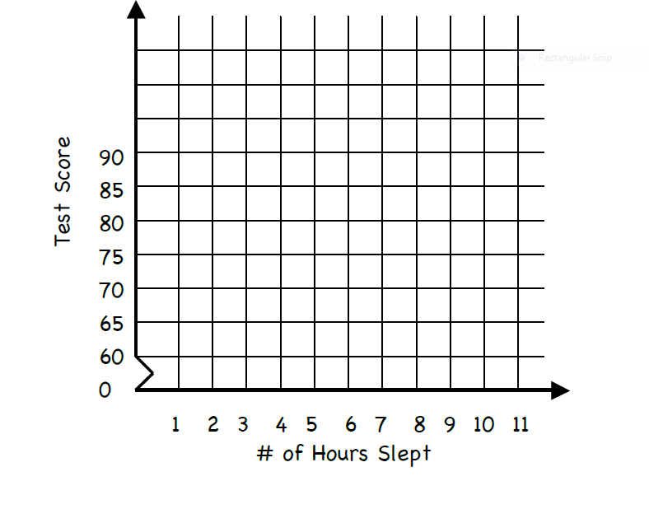

8. Assume that during a three-hour period spent outside, a person recorded the

temperature and their water consumption. The experiment was conducted on 7

randomly selected days during the summer. The data is shown in the table

below.

