**HW - Review DAY**

1. Which one has the greatest y-intercept? 2. Greatest rate of change?

** A. B. C. D.**

**y = -2x + 1** The function adds

two to the input.

|  |  |
| --- | --- |
| **x** | **y** |
| **- 1** | **1** |
| **1** | **3** |
| **3** | **5** |
| **5** | **7** |

3. Which one has the greatest y-intercept? 4. Greatest rate of change?

**K. L. M. N.**

|  |  |
| --- | --- |
| x | Y |
| -2 | 1 |
| -3 | 2 |
| -4 | 3 |
| -5 | 4 |

Y= -2x – 6 The function

multiples the

input by -2 and

adds three

to it.

5. Which verbal representation matches the function table?

|  |  |
| --- | --- |
| x | Y |
| -2 | -3 |
| -1 | -2 |
| 0 | -1 |
| 1 | 0 |

A. This function multiplies the input by 1 and then subtracts 2 from it.

B. This function multiplies the input by -1 and then subtracts 1 to it.

C. This function multiplies the input by -1/2 and then adds 1 to it.

D. This function multiplies the input by 1/2 and then subtracts 1 from it.

6. Write the algebraic representation for the function table in #5.

7. Jacob walking to football practice

[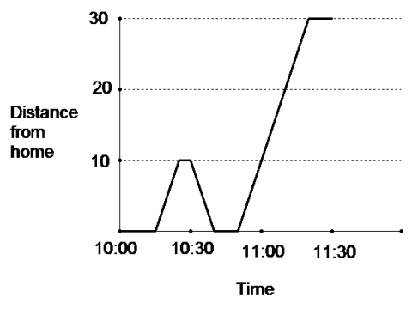](https://www.google.com/url?sa=i&rct=j&q=&esrc=s&source=images&cd=&cad=rja&uact=8&ved=0ahUKEwidvemU7vvQAhUk3IMKHZMsCfUQjRwIBw&url=http://www.suggest-keywords.com/Z3JhcGggc3Rvcmllcw/&psig=AFQjCNEwwUDFVeGWEk84WzD1SWRszHtrAw&ust=1482085827089951)

7a. How far from home is Jacob at 10:30?

b. How many times does he come home before 11:30?

c. What is the number of miles walked between 10:40 and 11:30?

d. At what times does Jacob rest?

(miles)

e. At what range does his speed increase ( from what time to what time)?

(OVER 🡪)

#8 Kareen’s Walk Across Michigan

[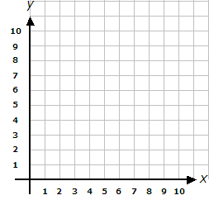](https://www.google.com/url?sa=i&rct=j&q=&esrc=s&source=images&cd=&cad=rja&uact=8&ved=0ahUKEwjz59qipurQAhVG6iYKHZ_pDy4QjRwIBw&url=http://www.helpingwithmath.com/printables/worksheets/geometry/geo0701coords11.htm&bvm=bv.141320020,d.eWE&psig=AFQjCNFXJRsEtw6utUjYDmcUkwDiS86jtg&ust=1481482427453393)

Which statement best interprets the information provided by the graph?

A. Kareen walked at a constant speed for the entire walk.

Distance B. Kareen rested three times during the walk.

(miles) C. She started to walk back home during day 6.

D. She spent 6 days resting.

Time (days)

Use these functions to answer #9-13

[](https://www.google.com/url?sa=i&rct=j&q=&esrc=s&source=images&cd=&cad=rja&uact=8&ved=0ahUKEwjz59qipurQAhVG6iYKHZ_pDy4QjRwIBw&url=http://www.helpingwithmath.com/printables/worksheets/geometry/geo0701coords11.htm&bvm=bv.141320020,d.eWE&psig=AFQjCNFXJRsEtw6utUjYDmcUkwDiS86jtg&ust=1481482427453393)A. PRICE FOR Wendy’s Fries B. PRICE FOR Burger King Fries

C = 2.45P

C. PRICE FOR Hardee’s Fries

COST ($) Fries cost $2.65 per sleeve.

D. PRICE FOR Famous Dave’s

|  |  |  |  |
| --- | --- | --- | --- |
| POUNDS | 2 | 4 | 6 |
| COST | 5.10 | 10.20 | 20.40 |

Sleeve of Fries

9. What is the cost per sleeve of Wendy’s Fries?

10. What is the cost per pound for Famous Daves Fries?

11. How much more is it for Burger King Fries versus Burger King fries?

12. What is the y-intercept for Wendy’s Fries.

13.  **TABLE Algebraic**

|  |  |
| --- | --- |
| x | Y |
| 2 | -2 |
| 3 | -1 |
| 4 | 0 |
| 5 | 1 |

y = 2x - 4

Which statement is true about these two functions?

A. The rate of change of the table function is less than the algebraic function.

B. The value of the y-intercept for both functions is the same.

C. The value of the y-intercept of table function is greater than the value of the algebraic.